CSS BRITISH HISTORY · TOPIC 5 · QUESTION ANSWERS
The Age of Reform, Parties, Peel, Gladstone and Ireland (1815–1928)
Every past question on parliamentary reform, Peel, Gladstone, the Irish Question and party politics — answered in full, in simple words, with answer maps

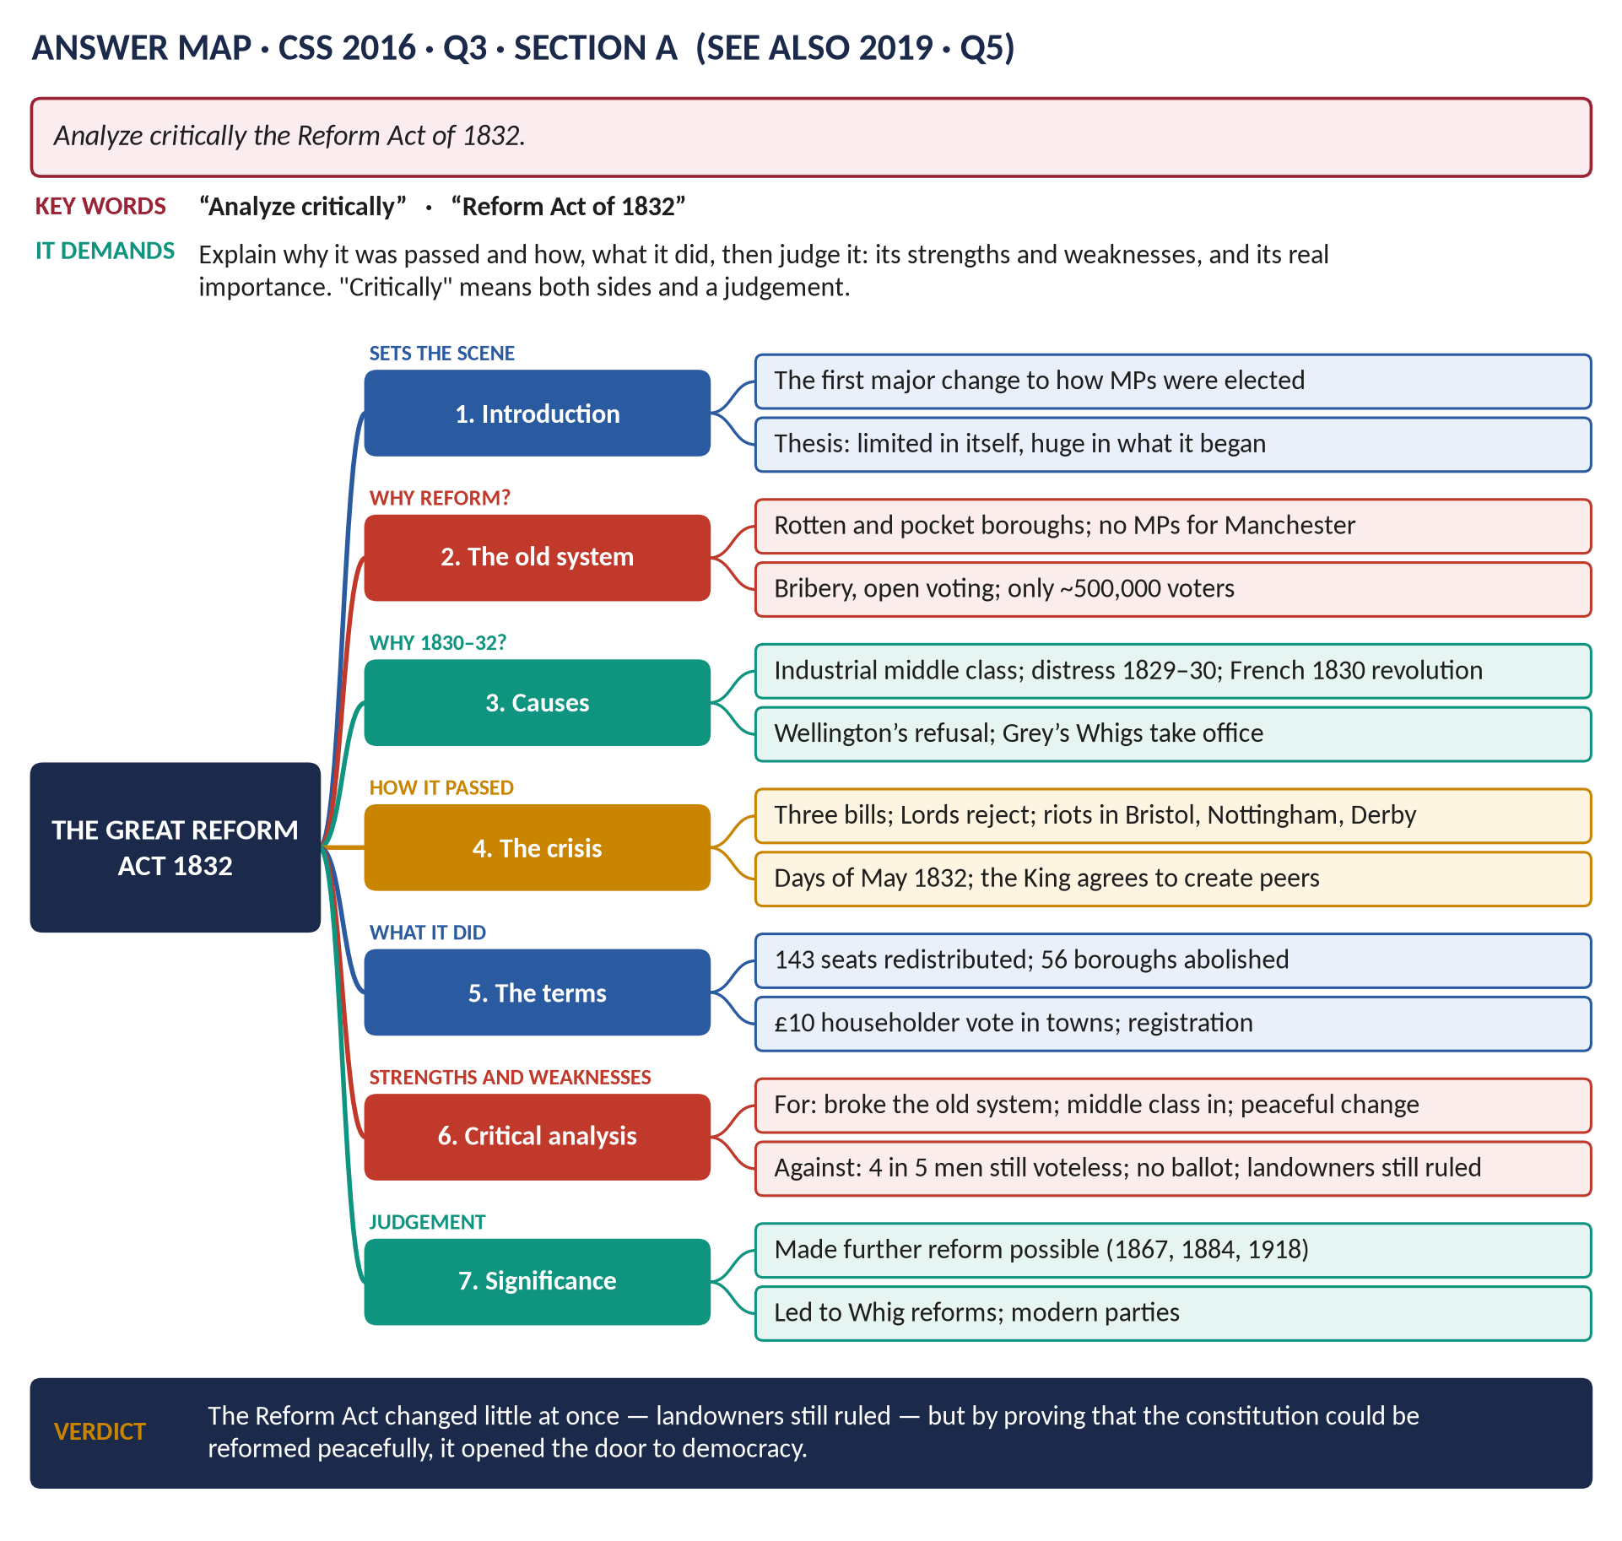
All 12 past questions (2015–2026): ten full answers and two repeats shown with their adaptations; the seven past MCQs solved; five predicted questions with outlines.
Topic 5 of 10 · companion to T5KB (the Knowledge Base)
Contents
HOW TO USE THIS · Updating the contents
Right-click the contents → Update Field → Update entire table, before saving as PDF.

How to Use These Answers 7
Answer 1 · William IV: The Short Reign and the Long Era of Bills and Acts 8
The model answer 9
Introduction 9
(1) Why so many laws came in these years 9
(2) Reforming Parliament itself — the Reform Act of 1832 9
(3) Humanitarian and social Acts 10
(4) Local government, the Church and the state 10
(5) Constitutional change 11
(6) The limits 11
Answer 2 · The Reform Act of 1832, Analysed Critically 13
The model answer 14
Introduction 14
(1) The unreformed system — why reform was needed 14
(2) Why it came in 1830–32 — the causes 15
(3) How it was passed — the crisis 15
(4) The terms — what the Act did 15
(5) Critical analysis — strengths 16
(6) Critical analysis — weaknesses 16
(7) Its real significance 16
Answer 3 · 1832 and the Foundations of Modern Britain 18
The model answer 19
Introduction 19
(1) The Act in brief 19
(2) How 1832 "made possible" later reform 19
(3) The political reforms 19
(4) The administrative reforms of the 1830s 20
(5) The administrative reforms of later decades 20
(6) Discussion — was it really 1832 that made them possible? 20
Answer 4 · Parliamentary Reform 1832–1928 and the Making of a Democracy 22
The model answer 23
Introduction 23
Limb 1 · The history of parliamentary reform, 1832–1928 23
(1) The Great Reform Act, 1832 23
(2) 1858 — MPs need not own property 24
(3) The Second Reform Act, 1867 24
(4) The Ballot Act, 1872 24
(5) The Corrupt and Illegal Practices Act, 1883 24
(6) The Third Reform Act, 1884, and the Redistribution Act, 1885 24
(7) The Parliament Act, 1911 24
(8) The Representation of the People Act, 1918 25
(9) The Equal Franchise Act, 1928 25
Limb 2 · How England became a democracy — critically examined 25
(10) The forces that drove reform 25
(11) The character of the process 25
(12) How complete was democracy in 1928? 26
Answer 5 · Measures for the Democratisation of the British Parliament 27
How to adapt Answer 4 27
Answer 6 · Peel's Methods of Governance and Those of His Predecessors 28
The model answer 29
Introduction 29
(1) Lord Liverpool (1812–27): the conciliator 29
(2) George Canning (1827): the orator 29
(3) The Duke of Wellington (1828–30): the soldier 29
(4) Peel's methods 30
(5) The similarities 30
(6) How far did they differ? 31
Answer 7 · Peel's Interior and Exterior Policy, with Emphasis on Ireland 32
The model answer 33
Introduction 33
Interior policy 33
(1) The first ministry and the Tamworth Manifesto (1834–35) 33
(2) Finance and the economy (1841–46) 34
(3) Social policy 34
(4) The repeal of the Corn Laws (1846) 34
The Irish issue — particular emphasis 35
(5) Peel and Ireland before 1841 35
(6) The problem in 1841 35
(7) Firmness: defeating Repeal 35
(8) Conciliation: "killing Repeal by kindness" 36
(9) The Great Famine (1845–46) 36
(10) Ireland and Peel's fall 36
Exterior policy 36
(11) Peace and conciliation under Aberdeen 36
(12) Empire and Asia 37
Assessment 37
Answer 8 · Peel: The Most Liberal of Conservatives and the Most Conservative of Liberals 38
The model answer 39
Introduction 39
(1) Understanding the terms 39
(2) The liberal Peel — "the most liberal of conservatives" 39
(3) The conservative Peel — "the most conservative of liberals" 39
(4) Reconciling the two — the Tamworth principle 40
(5) What contemporaries and historians said 40
(6) Critical judgement — is the statement fair? 40
Answer 9 · Gladstone's Domestic Policy: The Climax of Liberalism 42
The model answer 43
Introduction 43
(1) What was nineteenth-century liberalism? 43
(2) Finance — the foundations (as Chancellor) 44
(3) First ministry (1868–74): opening institutions to merit 44
(4) First ministry: education, rights and law 45
(5) Ireland — "justice for Ireland" 45
(6) Second, third and fourth ministries: democracy and rights 45
(7) Why it can be called the "climax" 45
(8) The limits — and what came after 46
Answer 10 · The Same Question, Set Again 47
How to reuse Answer 9 47
Answer 11 · The Irish Question and Liberal Policy, 1886–1894 48
The model answer 49
Introduction 49
Limb 1 · Defining the Irish Question 49
(1) The definition 49
(2) The three strands 49
(3) The background to 1886 50
Limb 2 · The Liberal policy, 1886–1894 51
(4) Why Gladstone adopted Home Rule 51
(5) The First Home Rule Bill (April 1886) 51
(6) The split and the Unionist years (1886–92) 51
(7) The Second Home Rule Bill (1893) 52
(8) Assessment of the Liberal policy 52
(9) The epilogue 52
Answer 12 · The Evolution of Party Politics in Nineteenth-Century Britain 54
The model answer 55
Introduction 55
(1) The starting point: politics in 1815 55
(2) Stage 1 · 1832–1846: the birth of modern parties 56
(3) Stage 2 · 1846–1867: fluid parties and a powerful Commons 56
(4) Stage 3 · 1867–1886: mass parties and party government 57
(5) Stage 4 · 1886–1900: realignment 57
(6) The changing relationship between government, Parliament and electorate — summarised 57
(7) Examination — why did party politics evolve this way? 58
Part Two — The Past MCQs, Solved 59
CSS 2024 · MCQ 19 59
CSS 2025 · MCQ 8 59
CSS 2025 · MCQ 10 59
CSS 2026 · MCQ 6 59
CSS 2026 · MCQ 7 60
CSS 2026 · MCQ 8 60
CSS 2026 · MCQ 16 60
Part Three — Five Predicted Questions, with Outlines 61
Predicted 1 · "Lord Liverpool's government moved from repression to reform. Discuss." 61
Predicted 2 · "Why were the Corn Laws repealed in 1846, and what were the consequences?" 61
Predicted 3 · "Assess Disraeli's contribution to the Conservative Party and to social reform." 61
Predicted 4 · "Discuss the causes and consequences of the Great Irish Famine (1845–49)." 62
Predicted 5 · "Examine the causes and significance of the Parliament Act of 1911." 62

How to Use These Answers
# | Paper | Question (short) | Answer
1 | 2015 P-I Q6 | William IV's short reign — "the long era of bills and acts" | Answer 1
2 | 2016 Q3 | Analyse critically the Reform Act of 1832 | Answer 2
3 | 2019 Q5 | 1832 made possible the reforms that founded modern Britain | Answer 3
4 | 2020 Q4 | Parliamentary reforms 1832–1928; how England became democratic | Answer 4
5 | 2018 Q5 | Measures to democratise Parliament — how to reuse Answer 4 | Answer 5
6 | 2024 Q1 | Peel's methods compared with Liverpool, Canning, Wellington | Answer 6
7 | 2018 Q4 | Peel's interior and exterior policy, with emphasis on Ireland | Answer 7
8 | 2020 Q5 | "The most liberal of conservatives and most conservative of liberals" | Answer 8
9 | 2017 Q5 | Gladstone's domestic policy — the climax of liberalism | Answer 9
10 | 2022 Q2 | Identical to 2017 Q5 — how to reuse Answer 9 | Answer 10
11 | 2024 Q2 | Define the Irish Question; Liberal policy 1886–94 | Answer 11
12 | 2025 Q4 | The evolution of party politics in the 19th century | Answer 12

Every answer has: the question as set · its answer map · decoding the question (what the examiner wants, in plain words) · a model answer with numbered headings, figures and a verdict · why this answer scores.
TRAP — DO NOT FALL INTO IT · Five reform questions, five different demands
The reform questions all use the same facts (T5KB, Chapters 2, 3 and 5) but ask different things: a reign (2015), one Act judged (2016), its consequences (2019), a century of Acts plus the reasons (2020), and the measures (2018). Never write one "Reform Act essay" for all of them. Build your headings from the words of the question in front of you.

HOW TO USE THIS · If you are new to this topic
Read T5KB Part Zero and Part One first — how Parliament worked and the story in simple words. Every answer below explains its hard words again, so it can be read on its own.

Answer 1 · William IV: The Short Reign and the Long Era of Bills and Acts
THE QUESTION · CSS 2015 · Q6 · Paper I · 20 marks
The short reign of William IV is considered to be the long era of bills and acts. Substantiate the statement with supportive arguments.

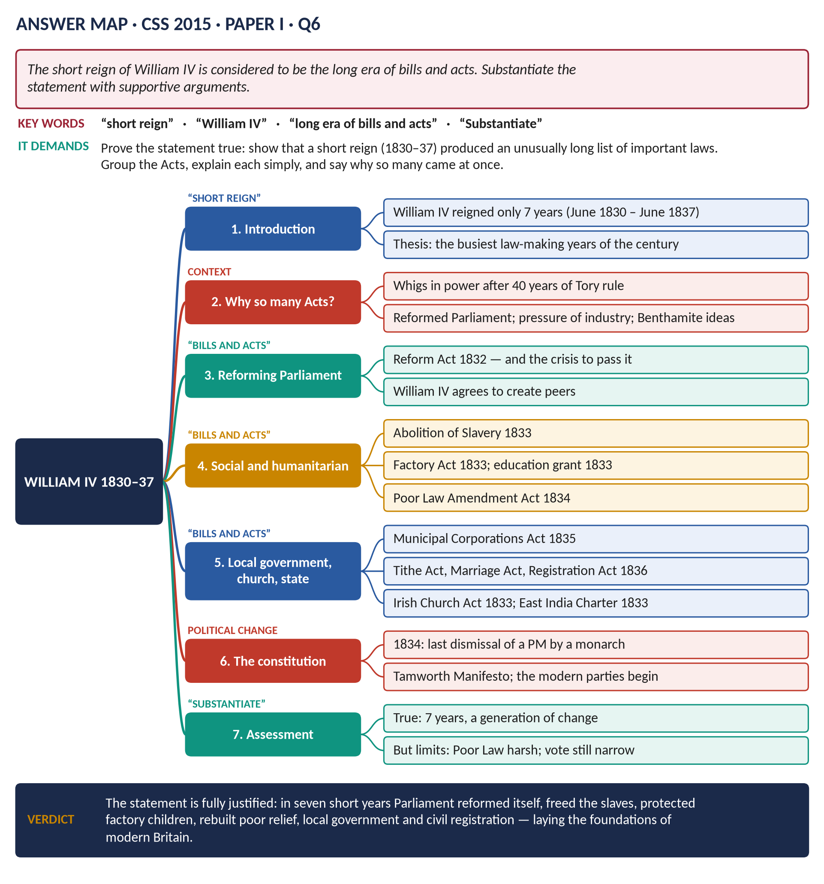
Figure 1 · The answer map for CSS 2015 · Q6 · Paper I: every branch is one heading of the answer below.
DECODING THE QUESTION
"Substantiate" means prove it with evidence — the examiner wants you to agree and support the statement with facts. "Short reign" = William IV reigned only seven years (1830–37). "Long era of bills and acts" = an unusually large number of important laws. So: show the laws, group them, explain what each did in simple words, and explain why so many came at once. A short note on the limits at the end shows balance.

The model answer

Introduction
William IV, the "Sailor King", came to the throne in June 1830 at the age of 64 and died in June 1837 — a reign of only seven years. Yet these years saw more important laws than any similar period of the nineteenth century. The Whigs, in power for the first time in almost fifty years, passed the Great Reform Act and then used the new Parliament to reform slavery, factories, the poor law, town government, the Church, marriage and registration. The statement that his short reign was "the long era of bills and acts" is fully justified.

(1) Why so many laws came in these years
- A change of government: the Tories had ruled almost without a break since 1783. In November 1830 the Whigs under Earl Grey took office with a long list of waiting reforms.
- A reformed Parliament: after 1832 the Commons included MPs for the industrial towns and more Nonconformists and middle-class men who wanted change.
- New problems: the Industrial Revolution (Topic 4) had created factories, crowded towns and new kinds of poverty that the old laws could not handle.
- New ideas: Jeremy Bentham's Utilitarianism — judge every law by whether it produces "the greatest happiness of the greatest number" — and a new method: a Royal Commission gathers evidence, Parliament passes a law, inspectors enforce it.
- Evangelical Christianity: a powerful moral campaign against slavery and cruelty.

(2) Reforming Parliament itself — the Reform Act of 1832
- The problem: tiny "rotten boroughs" like Old Sarum (no inhabitants) elected two MPs, while Manchester and Birmingham elected none; only about 500,000 men could vote.
- The struggle: the bill took three attempts; the Lords rejected it in 1831, causing riots in Bristol and Nottingham; in the "Days of May" 1832 William IV agreed to create new peers if needed, and the Lords gave way.
- The Act (7 June 1832): 143 seats redistributed; the vote for £10 householders in the towns; the electorate rose to about 813,000.
- Why it matters here: it was the key that opened the door to all the other Acts of the reign.

(3) Humanitarian and social Acts

(a) The Slavery Abolition Act (1833)
Slavery was abolished throughout the British Empire from 1 August 1834. About 800,000 enslaved people in the West Indies, the Cape and Mauritius were freed, though they had to work as "apprentices" until 1838. The owners received £20 million in compensation. The campaign had been led by William Wilberforce, who died just after hearing the bill would pass, and Thomas Fowell Buxton.

(b) The Factory Act (1833)
The first effective factory law: no children under 9 in textile mills; children aged 9–13 limited to 9 hours a day; young people under 18 to 12 hours; and, most important, four paid factory inspectors to enforce it.

(c) The first education grant (1833)
For the first time the state gave money for schools: £20,000 a year to the two church school societies. It was small, but it began the state's role in education.

(d) The Poor Law Amendment Act (1834)
The "New Poor Law" changed how the poor were helped. Parishes were grouped into unions, each with a workhouse; able-bodied people could get help only by entering it, where conditions were made deliberately hard ("less eligibility"); a central Poor Law Commission in London controlled the system. It was efficient and saved money, but it was hated by the poor — and helped cause Chartism (Topic 4).

(4) Local government, the Church and the state

(a) The Municipal Corporations Act (1835)
Before 1835 many towns were run by closed, corrupt corporations that chose their own members. The Act replaced them in 178 boroughs with councils elected by the ratepayers — the start of modern local government.

(b) The Church and religion
- Irish Church Temporalities Act (1833): reduced the number of Protestant bishops in Catholic Ireland.
- Tithe Commutation Act (1836): replaced the payment of a tenth of farm produce to the Church with a money rent.
- Marriage Act (1836): Nonconformists and Catholics could marry in their own chapels, and there was civil marriage before a registrar.

(c) Registration (1836)
The Births and Deaths Registration Act made the state record every birth, marriage and death from 1837 — the beginning of modern statistics.

(d) Empire and trade
The East India Company Charter Act (1833) ended the Company's trade monopoly with China; the Company became a governing body in India. The Bank Charter Act (1833) made Bank of England notes legal tender.

(e) A freer press
The stamp duty on newspapers was cut from 4d to 1d in 1836, so newspapers became cheaper.

(5) Constitutional change
The reign also changed the constitution:
- In 1832 the King sided with the Commons against the Lords — the Lords learned they could not block the will of the elected house for ever.
- In November 1834 William IV dismissed Lord Melbourne's Whig government and appointed Peel. Peel lost the election of 1835 and resigned after about 100 days. It was the last time a British monarch dismissed a Prime Minister — from now on, the voters decided.
- Peel's Tamworth Manifesto (1834) and the Whig–Radical–Irish Lichfield House Compact (1835) were the first signs of modern party politics.
Act | Year | In one line
Reform Act | 1832 | New towns get MPs; middle class gets the vote
Slavery Abolition Act | 1833 | Slavery ended in the empire
Factory Act | 1833 | Child labour limited; inspectors appointed
Education grant | 1833 | £20,000 — the state's first money for schools
Poor Law Amendment Act | 1834 | Workhouses; central control
Municipal Corporations Act | 1835 | Elected town councils
Tithe, Marriage, Registration Acts | 1836 | Civil marriage; births and deaths recorded

(6) The limits
To substantiate is not to exaggerate. The reforms had limits: the Reform Act left four men in five without a vote; the New Poor Law was harsh; freed slaves had to serve as apprentices; the factory law covered only textile mills. But these limits do not weaken the statement — they show that the reign began processes that later governments would continue.
VERDICT · Conclusion
In just seven years William IV's reign saw Parliament reform itself, abolish slavery, protect factory children, fund schools, rebuild poor relief, create elected town councils, reform the Church's privileges and begin civil registration — and it settled that the voters, not the King, chose the government. A short reign truly was a long era of bills and acts, and it laid many of the foundations of modern Britain.

WHY THIS ANSWER SCORES · Why this answer scores
It agrees and proves (which is what "substantiate" asks) · it explains why so many Acts came together · the Acts are grouped (Parliament; humanitarian; local and church; constitution) and each is explained in plain words with its date · a summary table · a short, honest section on limits adds balance without undermining the thesis.

Answer 2 · The Reform Act of 1832, Analysed Critically
THE QUESTION · CSS 2016 · Q3 · Section A · 20 marks
Analyze critically the Reform Act of 1832.

Figure 2 · The answer map for CSS 2016 · Q3 · Section A: every branch is one heading of the answer below.
DECODING THE QUESTION
"Analyze critically" = break the Act into its parts (causes, passage, terms, effects) and judge it — its strengths, its weaknesses, and its real importance. A purely descriptive answer loses marks; you must end with a clear judgement. (The same knowledge serves 2019 Q5, which asks only about its consequences.)

The model answer

Introduction
The Reform Act of 1832 — often called the Great Reform Act — was the first major change in how the House of Commons was elected. It removed the worst rotten boroughs, gave MPs to the new industrial towns, and gave the vote to middle-class men. Critically analysed, it was limited in what it did immediately — landowners still ruled and four men in five still had no vote — but enormous in what it made possible: it proved that the old constitution could be reformed peacefully, and so opened the road to democracy.

(1) The unreformed system — why reform was needed
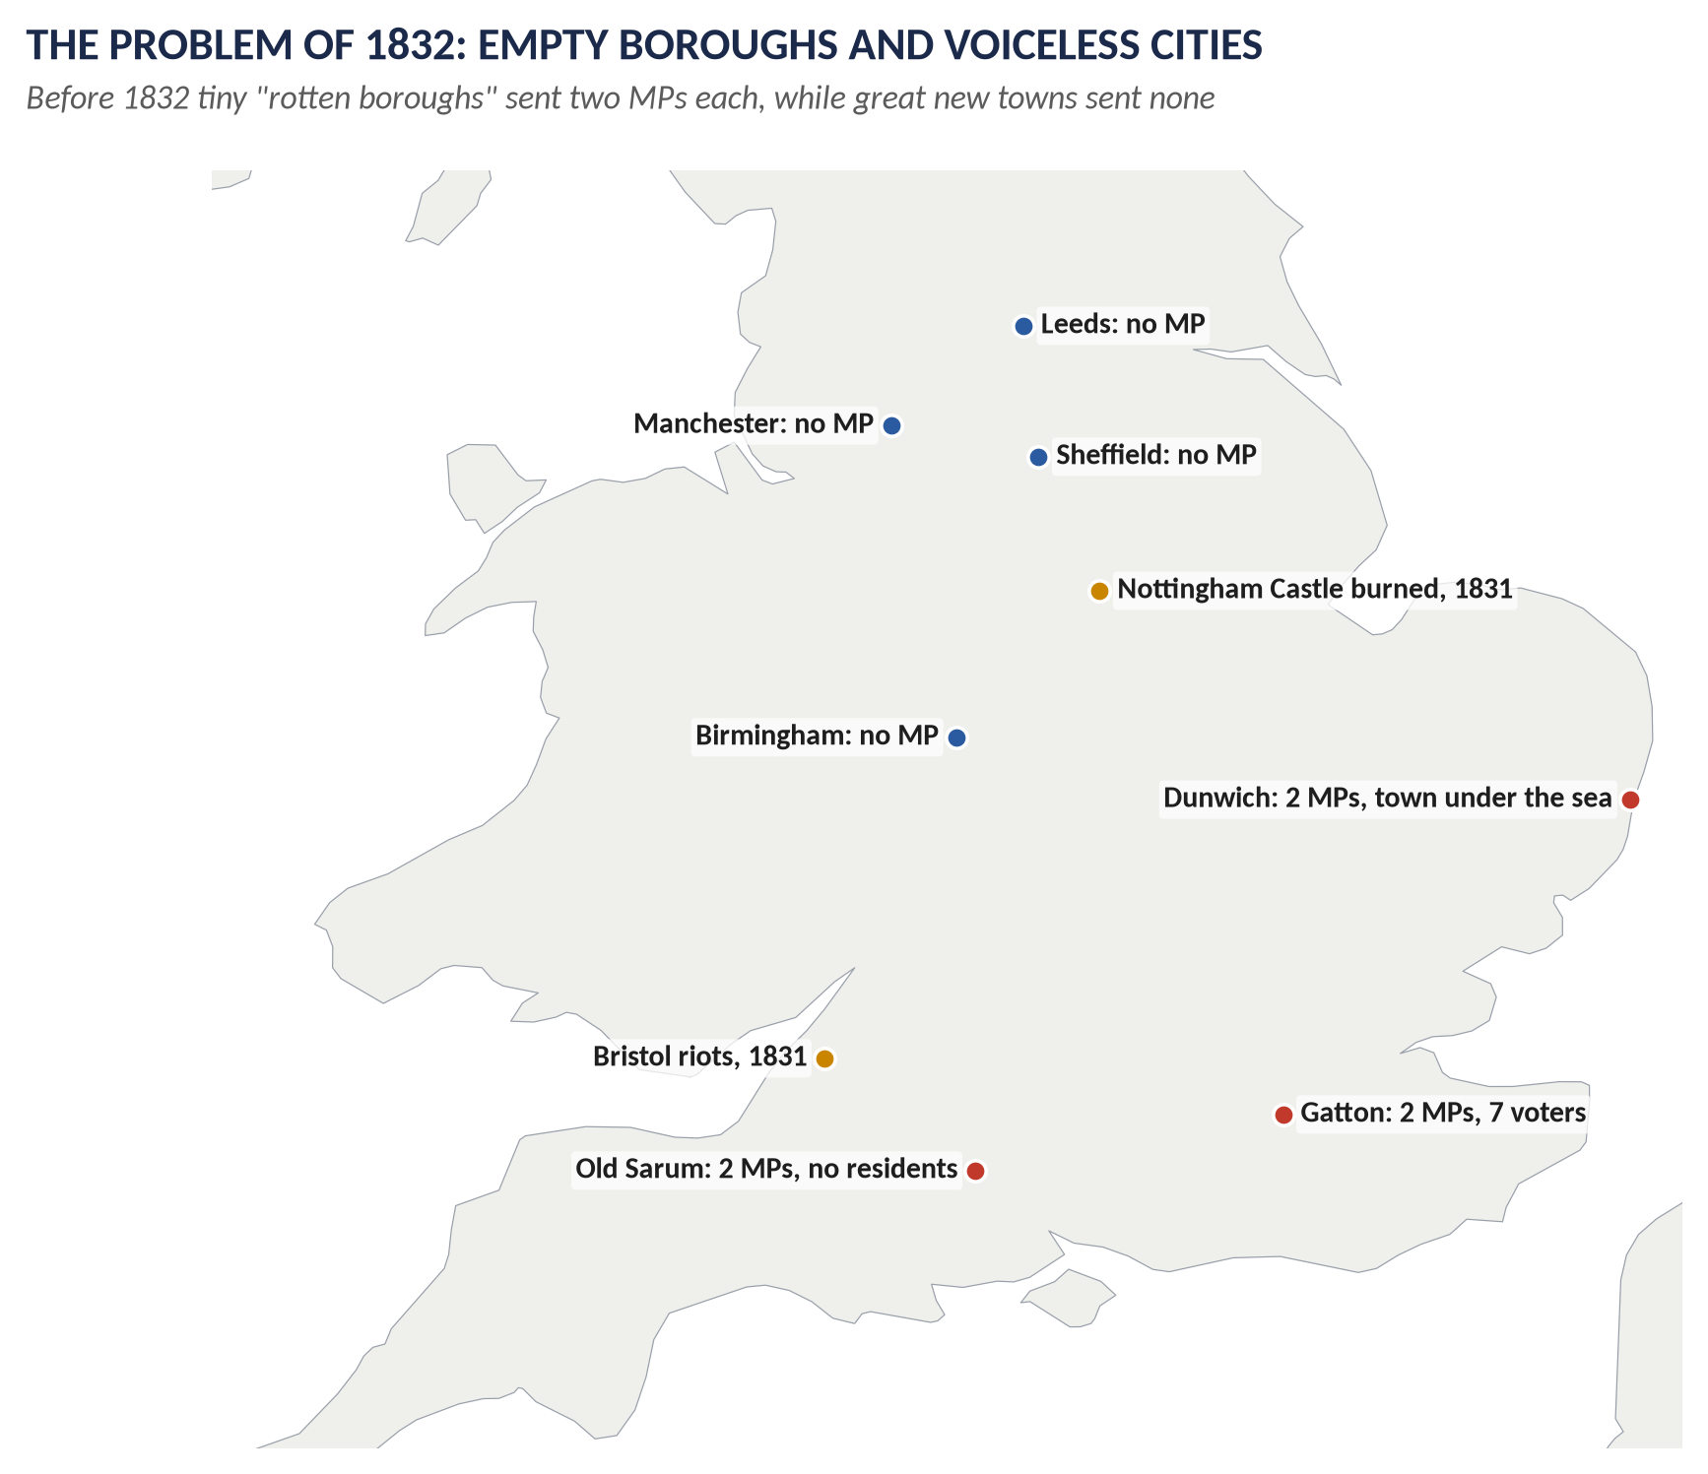
Figure 3 · Before 1832: empty boroughs with MPs, great cities without.
- Seats in the wrong places: Old Sarum, a deserted hill, and Gatton (7 voters) elected two MPs each; Dunwich was half under the sea. Manchester, Birmingham, Leeds and Sheffield — great new cities — had none. Cornwall had 44 MPs; the whole of Lancashire had 14.
- Pocket boroughs: many seats were controlled by a single landowner who chose the MP.
- A tiny, confused franchise: about 500,000 voters in the UK; the right to vote varied from borough to borough.
- Corruption: voting was open (in public), so landlords and employers could see how people voted; votes were openly bought.
- New classes without a voice: the industrial middle class created the nation's new wealth and paid taxes but had little say.

(2) Why it came in 1830–32 — the causes
1. The middle class demanded representation; the Political Unions, led by Thomas Attwood's Birmingham Political Union (1830), organised pressure.
2. Economic distress in 1829–30 and the Swing Riots of farm labourers.
3. The July Revolution in France (1830) showed what might happen if reform was refused.
4. Wellington's refusal: in November 1830 he declared the existing system perfect — and his government fell.
5. The Whigs' belief in "reform to preserve" (Macaulay): a limited reform would attach the middle class to the constitution and prevent revolution.

(3) How it was passed — the crisis
- March 1831: the first bill passed its second reading by one vote (302–301), then failed.
- 1831 election: Grey appealed to the voters on reform — and won a large majority.
- October 1831: the House of Lords rejected the second bill. There were riots — the centre of Bristol burned, Nottingham Castle was set on fire, Derby jail was attacked.
- May 1832: the "Days of May": the Lords wrecked the third bill; the King refused to create peers; Grey resigned; Wellington could not form a government; a run on the banks was threatened.
- June 1832: William IV promised to create enough new peers; the Lords gave way. Royal Assent, 7 June 1832.

(4) The terms — what the Act did

(a) Seats
- 56 small boroughs lost both MPs; 30 lost one.
- 143 seats redistributed: 22 large towns got two MPs, about 20 got one; the counties got 65 more.

(b) The vote
- Towns: all men occupying property worth £10 a year — the £10 householders.
- Counties: the old 40-shilling freeholders, plus £10 copyholders and leaseholders, and £50 tenants-at-will (the Chandos clause).
- Registration of voters.

(c) The numbers
The UK electorate rose from about 500,000 to about 813,000 — from roughly one adult man in ten to one in five.

(5) Critical analysis — strengths
1. It broke the old system: the worst rotten boroughs disappeared; the principle that seats should reflect population was admitted.
2. The middle class entered politics: the new industrial towns had MPs; a new class was attached to the constitution.
3. Change without revolution: Britain reformed by law while France, Belgium and Poland had revolutions in 1830.
4. The Lords and the Crown were weakened: the Lords had been forced to yield to the Commons and the people.
5. Registration led to modern party organisation.

(6) Critical analysis — weaknesses
1. Most people were still excluded: about four men in five and all women had no vote.
2. No secret ballot: bribery and intimidation went on until 1872.
3. Unequal constituencies: small southern boroughs still outnumbered the industrial north.
4. Landowners still dominated: most MPs and ministers were still landowners; the Commons of 1833 looked much like that of 1830.
5. Some lost the vote: in places like Preston working men had voted before 1832 and could not after.
6. The workers felt betrayed: they had campaigned for reform and got nothing — this led directly to Chartism (1838).
KEY IDEA · Two historians' views
Norman Gash stressed how little changed: the aristocracy kept its power. Asa Briggs and most others stress what it began: it was meant as a "final" settlement, but it made further reform inevitable.

(7) Its real significance
- It led at once to a flood of reforms: slavery (1833), factories (1833), the Poor Law (1834), town councils (1835).
- It started the staircase to democracy: 1867, 1884, 1918, 1928.
- It helped create the modern Conservative and Liberal parties.
VERDICT · Conclusion
Judged by what it did in 1832, the Reform Act was a modest measure that left power with the landowners and most people without a vote. Judged by what it made possible, it was one of the most important laws in British history: by showing that Parliament could reform itself peacefully, it began the century of reform that turned Britain into a democracy.

WHY THIS ANSWER SCORES · Why this answer scores
It analyses — causes, passage, terms, effects — and it is critical: strengths and weaknesses in two separate numbered lists and a historians' box · every point has a figure or date (56, 30, 143, £10, 813,000) · a clear two-sided judgement in the conclusion.

Answer 3 · 1832 and the Foundations of Modern Britain
THE QUESTION · CSS 2019 · Q5 · Section A · 20 marks
The Reform Act of 1832 made possible the series of political and administrative reforms that laid the foundation of modern Britain. Discuss.

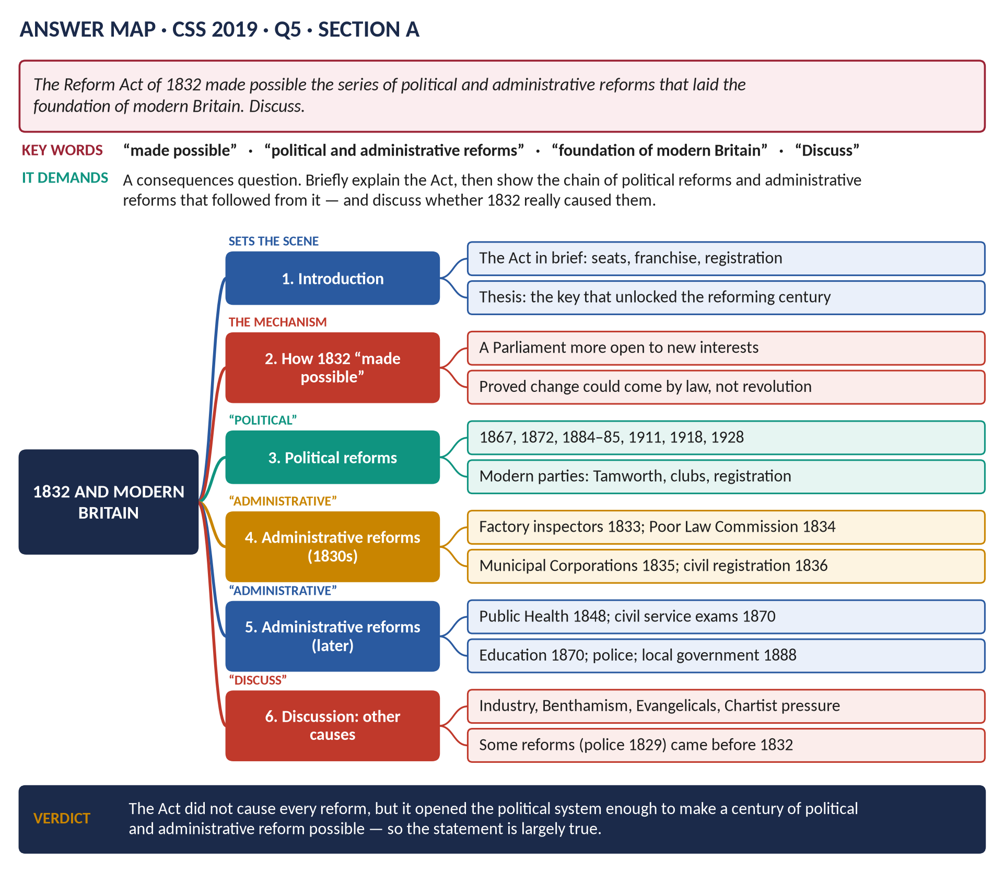
Figure 4 · The answer map for CSS 2019 · Q5 · Section A: every branch is one heading of the answer below.
DECODING THE QUESTION
The statement: "The Reform Act of 1832 made possible the series of political and administrative reforms that laid the foundation of modern Britain." "Discuss" = explain and weigh the argument, and give your view. This is a consequences question. Do not spend long on the Act itself — one short section — and give most of your answer to the political reforms and the administrative reforms that followed, and to whether 1832 really "made them possible".

The model answer

Introduction
The Reform Act of 1832 redistributed 143 seats, gave MPs to the industrial towns and gave the vote to middle-class men. Its direct effects were modest. But it changed the political system enough to allow a series of political reforms (towards democracy) and administrative reforms (the growth of a modern, professional state) over the following decades. This answer argues that the statement is largely true — 1832 was the key that unlocked reform — though other forces were also at work.

(1) The Act in brief
Rotten boroughs abolished; £10 householders in the towns and more county voters; the electorate 500,000 → 813,000; registration of voters. (See Answer 2.)

(2) How 1832 "made possible" later reform
- A different Parliament: MPs for Manchester and Birmingham; more Nonconformists; more middle-class opinion.
- A precedent: it proved that the constitution was not fixed — if it could be reformed once, it could be reformed again.
- The Lords defeated: after 1832 the Lords knew they could not permanently block a determined Commons.
- Whig government: the Act gave the reforming Whigs a large majority and a mandate.
- Registration forced parties to organise and to court new voters.

(3) The political reforms
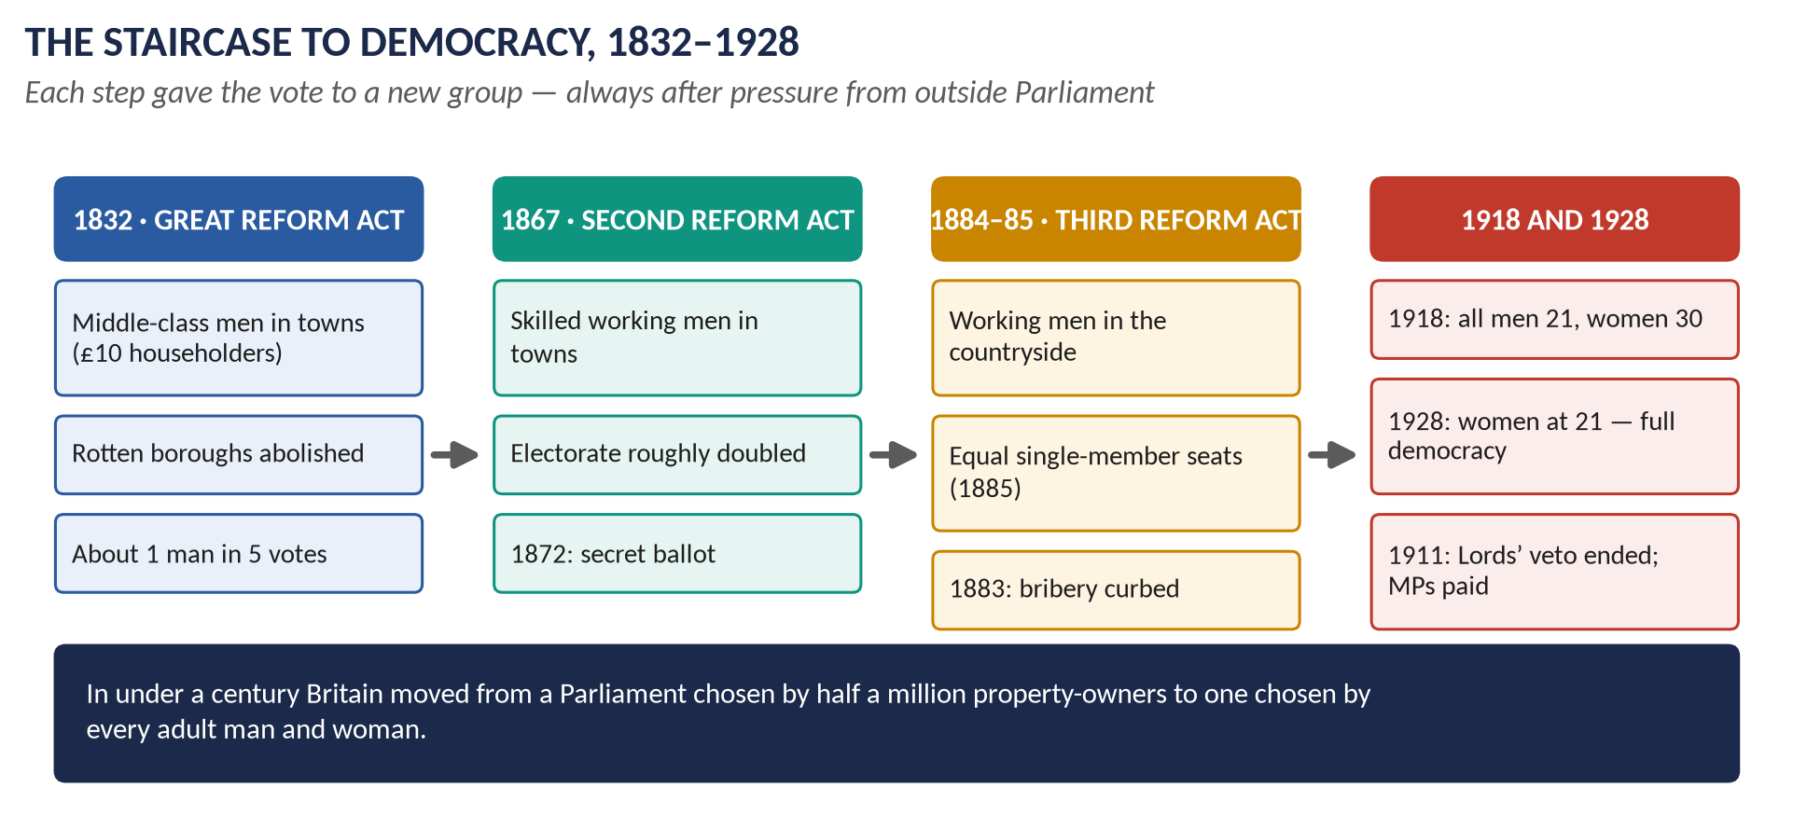
Figure 5 · The staircase to democracy that began in 1832.
- Further Reform Acts: 1867 (urban workers), 1884 (rural workers), 1885 (equal seats), 1918 (all men, women over 30), 1928 (women at 21).
- The Ballot Act (1872) and the Corrupt Practices Act (1883): free and fair elections.
- Property qualification for MPs abolished (1858); payment of MPs (1911); the Parliament Act (1911) ended the Lords' veto.
- Modern parties: the Tamworth Manifesto (1834), the Carlton and Reform clubs, the Liberal Party (1859), mass party organisations after 1867.
- The Crown's retreat: William IV's failure in 1834 was the last royal dismissal of a PM.

(4) The administrative reforms of the 1830s
An administrative reform creates or improves the machinery of government — departments, officials, inspectors, local authorities.
- Factory Act (1833): the first paid inspectors — the state began to watch working conditions.
- Poor Law Amendment Act (1834): a central Poor Law Commission, with local boards and paid officials.
- Municipal Corporations Act (1835): elected town councils — the base of modern local government.
- Registration Act (1836): the General Register Office recorded births, marriages and deaths.
- Education grant (1833), supervised from 1839 by a Committee of the Privy Council on Education with school inspectors.

(5) The administrative reforms of later decades
- Public Health Act (1848): a General Board of Health and local boards (after Chadwick's report, 1842).
- Civil Service reform: the Northcote–Trevelyan Report (1854) and open competitive examination (1870) — a professional civil service chosen by merit.
- Police: county police forces (1839, compulsory 1856).
- Education Act (1870): school boards.
- Local Government Act (1888): elected county councils; 1894: parish and district councils.
KEY IDEA · The foundation of modern Britain
Democracy (the vote), a professional civil service, inspectors, elected local councils, public health and state education are all features of modern Britain — and the chain of laws that created them began in the reformed Parliament after 1832.

(6) Discussion — was it really 1832 that made them possible?
- Other causes: the Industrial Revolution created the problems; Benthamite ideas supplied the method; Evangelicals supplied the moral drive; Chartists and later movements supplied pressure from below.
- Some reforms came before 1832: the Metropolitan Police (1829), Catholic Emancipation (1829), the repeal of the Combination Acts (1824).
- Some came slowly: the franchise stayed narrow for 35 years; the aristocracy dominated cabinets until the 1880s.
- But: without 1832, the unreformed Parliament of landowners would hardly have passed the factory, poor law and municipal Acts of the 1830s, and the precedent of reform would not have existed.
VERDICT · Conclusion
The statement is largely true. The Reform Act did not itself create modern Britain, and other forces were at work, but it opened the political system just enough to make possible a century of political reform — towards democracy — and administrative reform — towards a professional, active state. In that sense it laid the foundation on which modern Britain was built.

WHY THIS ANSWER SCORES · Why this answer scores
It keeps the Act itself short and spends its space on the consequences the question asks for · political and administrative reforms have separate headings, as the question names them · it explains what "administrative" means · the "Discuss" section weighs other causes and early reforms before a clear conclusion.

Answer 4 · Parliamentary Reform 1832–1928 and the Making of a Democracy
THE QUESTION · CSS 2020 · Q4 · Section A · 20 marks
Give a history of parliamentary reforms between 1832 and 1928. Also critically examine how England became a politically democratic country.


Figure 6 · The answer map for CSS 2020 · Q4 · Section A: every branch is one heading of the answer below.
DECODING THE QUESTION
Two limbs. (1) "Give a history of parliamentary reforms between 1832 and 1928" — tell the story of each reform in order, with its date, what it did and who gained. (2) "Critically examine how England became a politically democratic country" — explain why and by what process Britain became a democracy, and judge that process (how complete, how fast, from above or below). Define democracy first.

The model answer

Introduction
A country is a political democracy when every adult citizen has an equal vote, cast freely and secretly, in fair elections that decide who governs. In 1831 Britain was far from this: about 500,000 men could vote, openly, in unequal constituencies, and the unelected Lords could block the Commons. By 1928 some 29 million men and women had equal, secret votes, and the Commons was supreme. The change came through a series of Acts, each won by pressure from outside Parliament and rivalry between the parties inside it — a slow, peaceful, evolutionary road.
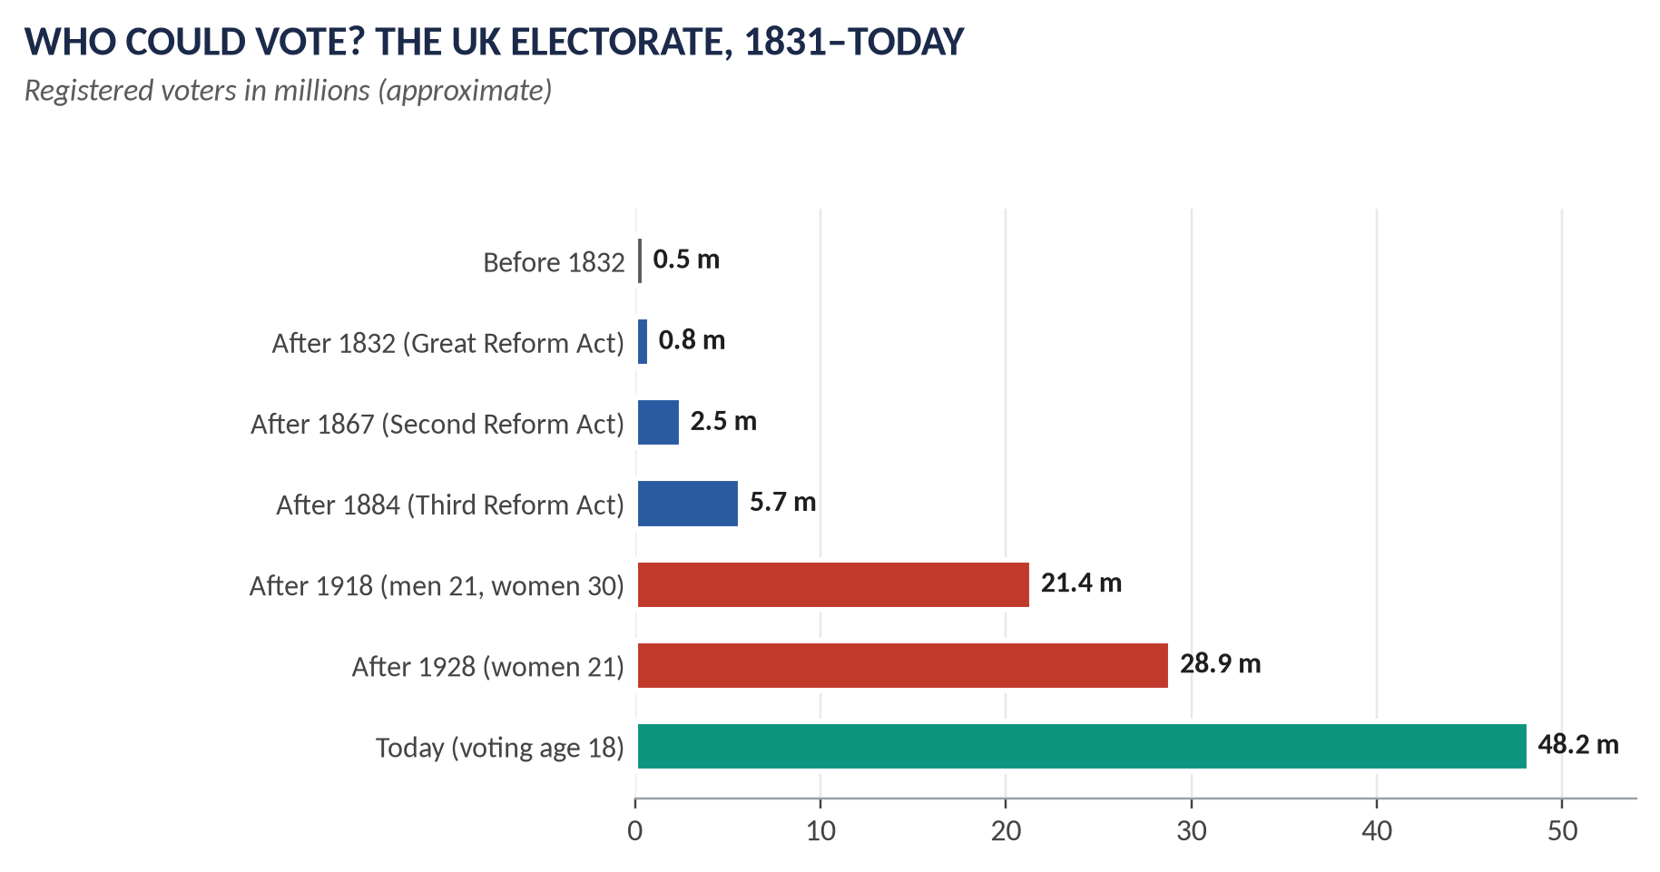
Figure 7 · From half a million to 29 million voters.

Limb 1 · The history of parliamentary reform, 1832–1928

(1) The Great Reform Act, 1832
- Passed by: the Whigs under Earl Grey, after a two-year crisis (riots, the Days of May, the threat to create peers).
- What it did: 143 seats redistributed from rotten boroughs to the new towns and counties; the vote for £10 householders in the towns; voter registration.
- Who gained: the middle class. Electorate about 500,000 → 813,000 (one man in five).

(2) 1858 — MPs need not own property
The property qualification for MPs was abolished — one of the six points of the Chartists (Topic 4).

(3) The Second Reform Act, 1867
- Background: the death of Palmerston (1865) reopened the question; the Liberal bill of Gladstone and Russell failed (1866); the Reform League held a mass meeting in Hyde Park (July 1866) and the railings were torn down.
- Passed by: the Conservative government of Lord Derby, carried through the Commons by Benjamin Disraeli — who accepted amendments that made it far bigger than planned. Disraeli "dished the Whigs" and hoped the new voters would be grateful.
- What it did: the vote for all male householders in the boroughs and for £10 lodgers; in the counties, £12 occupiers. 45 seats redistributed.
- Who gained: the urban working class. Electorate about 1.4 million → 2.5 million.
- Reaction: Lord Derby called it "a leap in the dark"; Robert Lowe: "we must educate our masters".

(4) The Ballot Act, 1872
Gladstone's Liberal government introduced secret voting on printed ballot papers. Landlords and employers could no longer see how their tenants and workers voted; election-day violence faded.

(5) The Corrupt and Illegal Practices Act, 1883
Strict limits on how much each candidate could spend; bribery and "treating" (buying drinks for voters) heavily punished. Elections became much cleaner.

(6) The Third Reform Act, 1884, and the Redistribution Act, 1885
- 1884: the household vote was extended to the counties — farm labourers and miners. Electorate about 3.1 million → 5.7 million — about two men in three.
- 1885: most constituencies became single-member seats of roughly equal size (about 50,000 people each) — the modern constituency map.

(7) The Parliament Act, 1911
- Background: the Lords rejected Lloyd George's "People's Budget" (1909); two elections (1910); the King agreed to create peers if necessary.
- What it did: the Lords could no longer veto bills passed by the Commons — only delay them for two years; money bills could not be delayed; elections at least every five years instead of seven.
- In the same year, MPs were paid (£400 a year) — so working men could afford to sit.

(8) The Representation of the People Act, 1918
- Background: the suffragists (Millicent Fawcett) and suffragettes (Emmeline Pankhurst, "Deeds not words", 1903–14); the First World War — soldiers who had fought and women who had worked in munitions could not be refused.
- What it did: the vote for all men over 21 (and soldiers over 19) and women over 30 who met a small property qualification; women could be MPs. Electorate about 7.7 million → 21.4 million.

(9) The Equal Franchise Act, 1928
Passed by Stanley Baldwin's Conservative government: women got the vote at 21, on exactly the same terms as men. Electorate about 28.9 million. Emmeline Pankhurst died weeks before it came into force.
Year | Who gained | Key feature
1832 | Middle-class men | Seats to new towns
1867 | Urban working men | Electorate doubled
1872 | All voters | Secret ballot
1884–85 | Rural working men | Equal single-member seats
1911 | The Commons | Lords' veto ended; MPs paid
1918 | All men 21+; women 30+ | Mass democracy
1928 | Women 21–30 | Equal franchise

Limb 2 · How England became a democracy — critically examined

(10) The forces that drove reform
1. Pressure from outside Parliament: the Political Unions and riots of 1831–32; Chartism (1838–48); the Reform League (1866); the suffrage movements (1897–1914). Each great Act followed a wave of popular pressure.
2. Rivalry between the parties: Conservatives and Liberals each hoped to win the new voters — Disraeli in 1867, Gladstone in 1884.
3. Economic and social change: industry, towns, trade unions, railways, newspapers and schools (1870) created a literate, organised people.
4. Liberal ideas: J. S. Mill argued for representative government and votes for women; the belief that citizens should share in government.
5. War: the First World War made universal suffrage impossible to refuse.

(11) The character of the process
- Gradual: 96 years, in five main steps.
- Peaceful and legal: every change was an Act of Parliament; Britain avoided the revolutions of 1830, 1848 and 1871 in France.
- From above: the ruling classes gave ground carefully, often to preserve their influence ("reform to preserve").
- Pragmatic: each step solved the immediate problem; there was no written constitution or grand plan.

(12) How complete was democracy in 1928?
- Not quite complete: plural voting (a second vote for university graduates and business owners) lasted until 1948; the House of Lords was still unelected; the voting age was 21 (18 only from 1969).
- But the essentials were there: every adult had a vote; voting was secret; seats were roughly equal; the elected Commons could overrule the Lords.
VERDICT · Conclusion
Between 1832 and 1928 a series of Reform Acts took Britain from an electorate of half a million property-owners to one of 29 million men and women. England became a democracy not through revolution but through gradual, peaceful laws, passed by a Parliament that gave way to pressure from outside and to the competition of the parties inside. The process was slow and came from above, but it was lasting — and it is the road that Britain has followed ever since.

WHY THIS ANSWER SCORES · Why this answer scores
Both limbs are clearly separated with headings · the history is complete, in order, with dates, who passed each Act, who gained and electorate figures · the "how" is analysed into five forces, not just narrated · the "critically" is met by examining the character and completeness of democracy · a summary table helps the examiner.

Answer 5 · Measures for the Democratisation of the British Parliament
THE QUESTION · CSS 2018 · Q5 · Section A · 20 marks
What measures were taken for the democratisation of the British Parliament over the decades?

DECODING THE QUESTION
The full question: "What measures were taken for the democratisation of the British Parliament over the decades?" This is Limb 1 of Answer 4, asked as "measures". Democratisation = making Parliament more democratic — more people voting, fairer elections, the elected house supreme. The examiner wants the measures, in order, each explained.

How to adapt Answer 4
1. Introduction: define democratisation under three headings you will use: (a) who can vote (the franchise), (b) how fair elections are (ballot, bribery, equal seats), (c) the power of the elected house (the Lords and the Crown).
2. Group the measures from Answer 4 under those three headings instead of strict date order:
  - (a) Franchise: 1832, 1867, 1884, 1918, 1928; add 1948 (plural voting ended) and 1969 (voting at 18), because "over the decades" allows you to go beyond 1928.
  - (b) Fair elections: 1858 (no property qualification), 1872 (secret ballot), 1883 (corrupt practices), 1885 (equal single-member seats), 1911 (payment of MPs).
  - (c) Power of the Commons: 1832 (Lords forced to yield), 1834 (last royal dismissal), 1911 and 1949 Parliament Acts, 1958 life peers, 1999 House of Lords Act.
3. Use the summary table from Answer 4 and the electorate chart.
4. Keep section (10) of Answer 4 briefly, as "why these measures were taken".
5. Conclusion: democratisation was gradual, peaceful, and still continuing — mention the 2025 plan for votes at 16.
WHY THIS ANSWER SCORES · Why this works
"What measures" is a describe question; grouping the measures by what they democratised turns a list into an analysis, and going beyond 1928 answers "over the decades".

Answer 6 · Peel's Methods of Governance and Those of His Predecessors
THE QUESTION · CSS 2024 · Q1 · Section A · 20 marks
How far did Robert Peel's methods of governance differ from those of his predecessors, viz. Liverpool, Canning and Wellington?

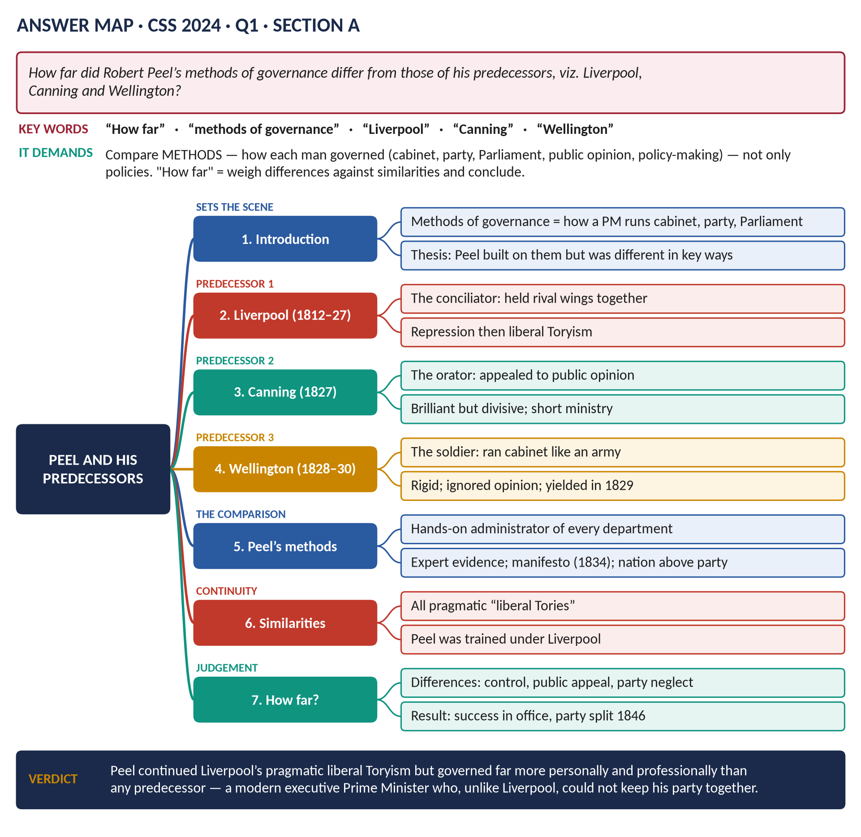
Figure 8 · The answer map for CSS 2024 · Q1 · Section A: every branch is one heading of the answer below.
DECODING THE QUESTION
"Methods of governance" means how a Prime Minister governed — how he ran the cabinet, managed his party, handled Parliament, used public opinion, and made policy — not simply what laws he passed. "How far did … differ" = compare Peel with Liverpool, Canning and Wellington, show both differences and similarities, and end with a judgement of degree ("largely", "in some ways").

The model answer

Introduction
Sir Robert Peel (Prime Minister 1834–35 and 1841–46) followed three Tory Prime Ministers: Lord Liverpool (1812–27), George Canning (1827) and the Duke of Wellington (1828–30). He had served under all of them. This answer compares their methods of governance — the way they ran cabinet, party, Parliament and policy. It argues that Peel continued their pragmatic "liberal Toryism" but governed in a strikingly different way: more personal, more professional, more evidence-based and more national — which made him a great administrator but cost him his party.

(1) Lord Liverpool (1812–27): the conciliator
- Cabinet: Liverpool was a chairman, not a boss. He let able ministers — Castlereagh, Canning, Peel, Huskisson — run their own departments.
- Party: his great skill was holding together two wings — the rigid "Ultras" and the "liberal Tories" — by compromise and patience. He left Catholic Emancipation an "open question" so ministers could disagree.
- Parliament and Crown: he kept the confidence of an awkward King (George IV) and of the Commons.
- Policy: pragmatic — repression in 1815–20 (Six Acts), reform in 1822–27 when conditions changed.
- Public opinion: little direct appeal to it.

(2) George Canning (1827): the orator
- Style: a brilliant speaker who appealed to public opinion and the press, especially in foreign policy.
- Party: divisive — Wellington, Peel and the Ultras refused to serve under him; he formed a government with some Whigs.
- Cabinet: a fragile coalition; he died after 119 days, so he had no time to develop a system.

(3) The Duke of Wellington (1828–30): the soldier
- Cabinet: he treated ministers like officers under his command; he lost the Canningites (Huskisson) in 1828 after a quarrel.
- Party: he outraged the Ultras by passing Catholic Emancipation (1829), then lost the reformers by refusing parliamentary reform (1830) — so he lost both wings.
- Policy: resist change until it could not be resisted, then give way suddenly.
- Public opinion: he despised it — his declaration against reform (November 1830) brought him down.

(4) Peel's methods

(a) A hands-on executive
Peel supervised every department. He read the papers of all his ministers, drafted his budgets himself (1842, 1845), and worked exceptionally long hours. Gladstone said Peel was the model of a working Prime Minister. No predecessor had controlled government so closely.

(b) Policy based on evidence
He used Royal Commissions, select committees and statistics — the Devon Commission on Irish land, the reports on mines and factories. He changed his mind when the evidence changed: on Catholic Emancipation (1829) and on the Corn Laws (1846).

(c) Appeal to the nation
The Tamworth Manifesto (1834) was addressed to the whole country — the first party manifesto. Peel claimed to govern for "the national interest", not for a class or a party.

(d) Building a party — and then ignoring it
- He built the modern Conservative Party: Tamworth, the Carlton Club (1832), a party agent (F. R. Bonham), registration societies — the victory of 1841.
- But in office he treated his backbenchers coldly and expected them to follow him. When he repealed the Corn Laws, two-thirds of his party voted against him, and the party split for twenty years.

(e) Strong government, cautious reform
Like Liverpool, Peel combined order (the police, coercion in Ireland) with reform (tariffs, banking, the Mines Act). Like Wellington, he gave way on great issues — but by conviction, after studying the evidence, not simply by force of circumstances.
Method | Liverpool | Canning · Wellington | Peel
Cabinet | Chairman; ministers free | Coalition · Commander | Directed every department
Party | Held it together | Split it · Lost both wings | Built it, then broke it
Public opinion | Little appeal | Appealed · Ignored | Appealed to the nation
Policy-making | Pragmatic compromise | Foreign policy · Resist then yield | Evidence and conviction
Result | 15 years in office | 119 days · 2 years | Great reforms; party split 1846

(5) The similarities
- All four were pragmatic Tories rather than ideologues.
- Peel was trained under Liverpool; his free-trade budgets continued Huskisson's tariff reforms, and his Home Office reforms began under Liverpool.
- Like Wellington, he gave way on Catholic Emancipation to avoid civil war in Ireland.
- All believed in strong executive government by the Crown's ministers.

(6) How far did they differ?
- Greatly in the personal control Peel exercised, his professional, evidence-based method, and his national appeal — all new, and all features of the modern Prime Minister.
- Greatly in party management: Liverpool's genius was to keep his party together; Peel's weakness was to put policy above party.
- Less in policy: Peel continued the liberal Toryism of the 1820s.
VERDICT · Conclusion
Peel's methods differed substantially from those of his predecessors. He shared Liverpool's pragmatism and continued the liberal Tory reforms of the 1820s, but he governed far more personally, professionally and on evidence than Liverpool, Canning or Wellington, and he appealed to the nation rather than to his party. These methods made him the first modern Prime Minister — and, unlike Liverpool, a leader who could not keep his party together when policy and party collided in 1846.

WHY THIS ANSWER SCORES · Why this answer scores
It defines "methods of governance" and sticks to methods, not just policies · each predecessor gets his own section · Peel is compared point by point in a comparison table · similarities as well as differences · the conclusion answers "how far" with a word of degree ("substantially") and a reason.

Answer 7 · Peel's Interior and Exterior Policy, with Emphasis on Ireland
THE QUESTION · CSS 2018 · Q4 · Section A · 20 marks
Shed ample light on the interior as well as exterior policy of Sir Robert Peel as British Premier, with particular emphasis on the Irish issue.

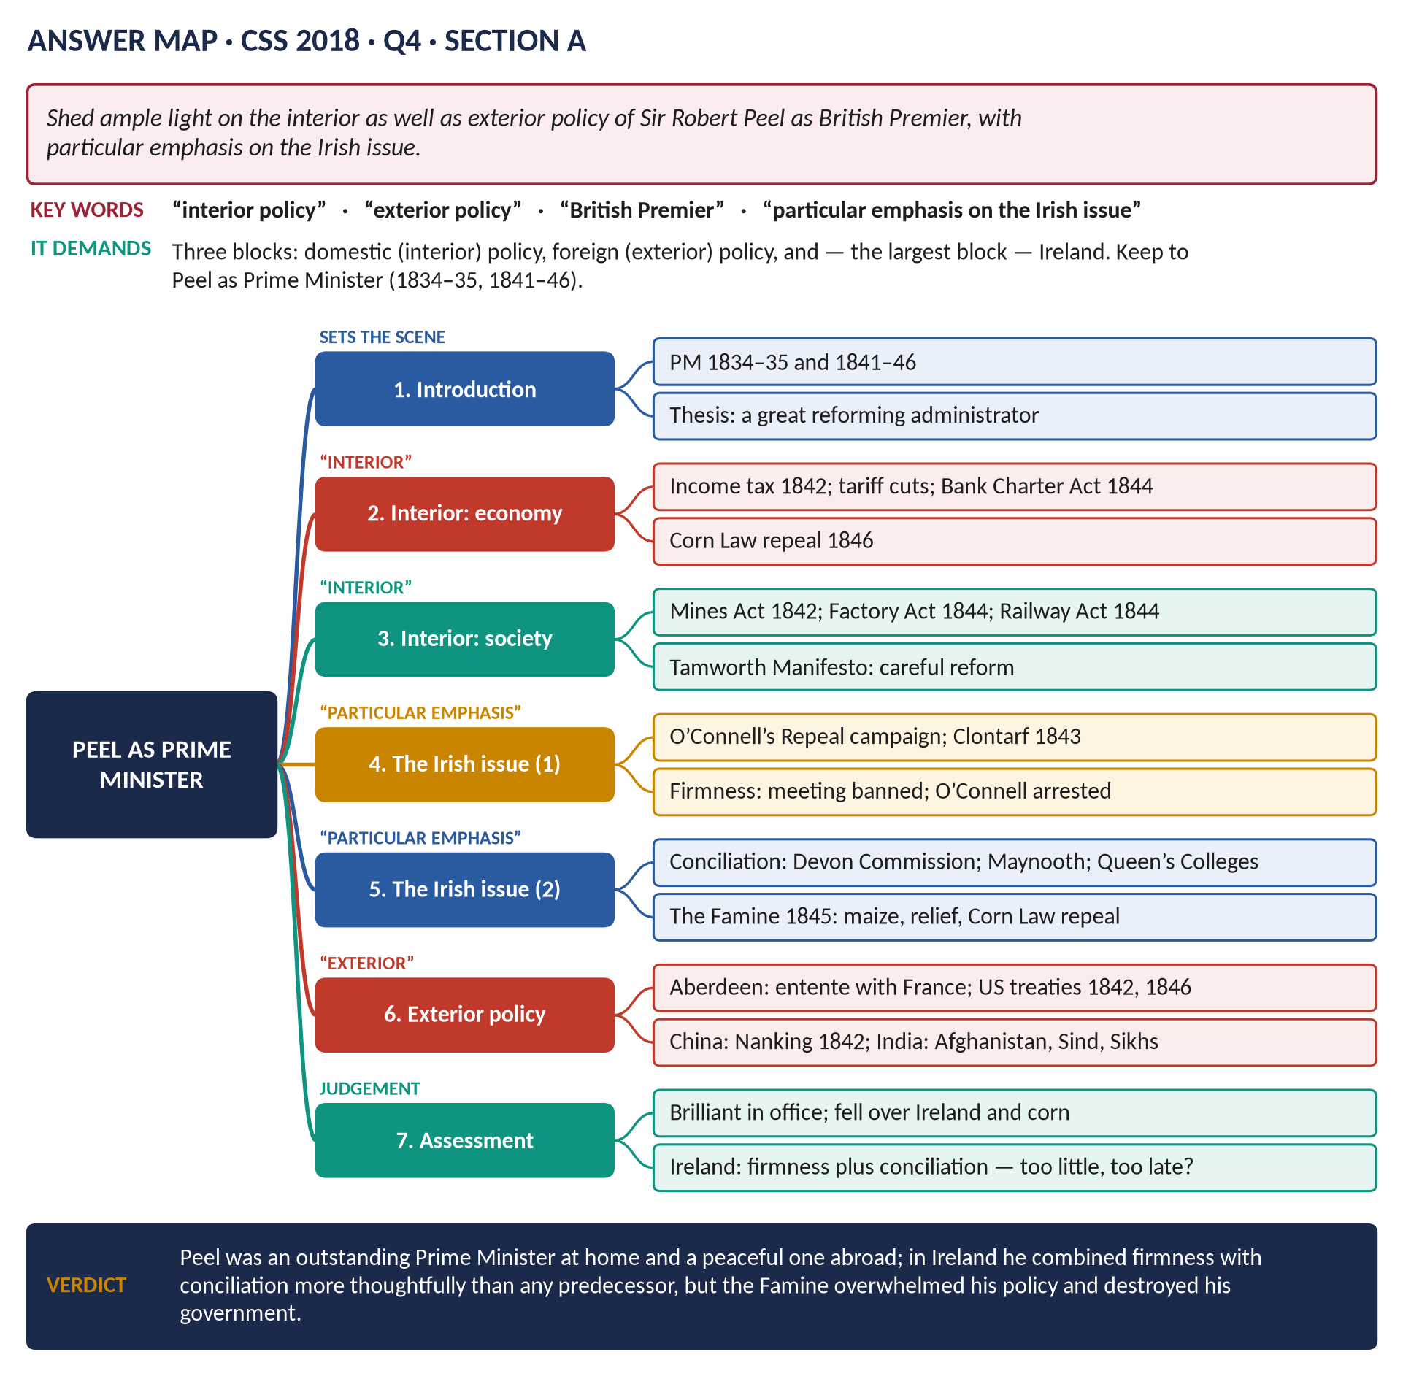
Figure 9 · The answer map for CSS 2018 · Q4 · Section A: every branch is one heading of the answer below.
DECODING THE QUESTION
"Shed ample light" = explain in full detail. "Interior policy" = domestic policy (economy, society, law). "Exterior policy" = foreign and imperial policy. "As British Premier" = as Prime Minister (1834–35, 1841–46) — mention his Home Office work only as background. "With particular emphasis on the Irish issue" = Ireland must be the largest section. Plan the space: about a quarter domestic, a sixth foreign, and at least a third on Ireland.

The model answer

Introduction
Sir Robert Peel was Prime Minister twice: briefly in 1834–35, and with a strong majority from 1841 to 1846. His ministry of 1841–46 is often called one of the greatest of the century. At home he restored the nation's finances, moved Britain towards free trade and passed important social laws; abroad his foreign secretary Lord Aberdeen kept the peace; and in Ireland — the problem he knew best — he combined firmness with a genuine policy of conciliation, until the Great Famine overwhelmed him and led to the repeal of the Corn Laws and his fall.
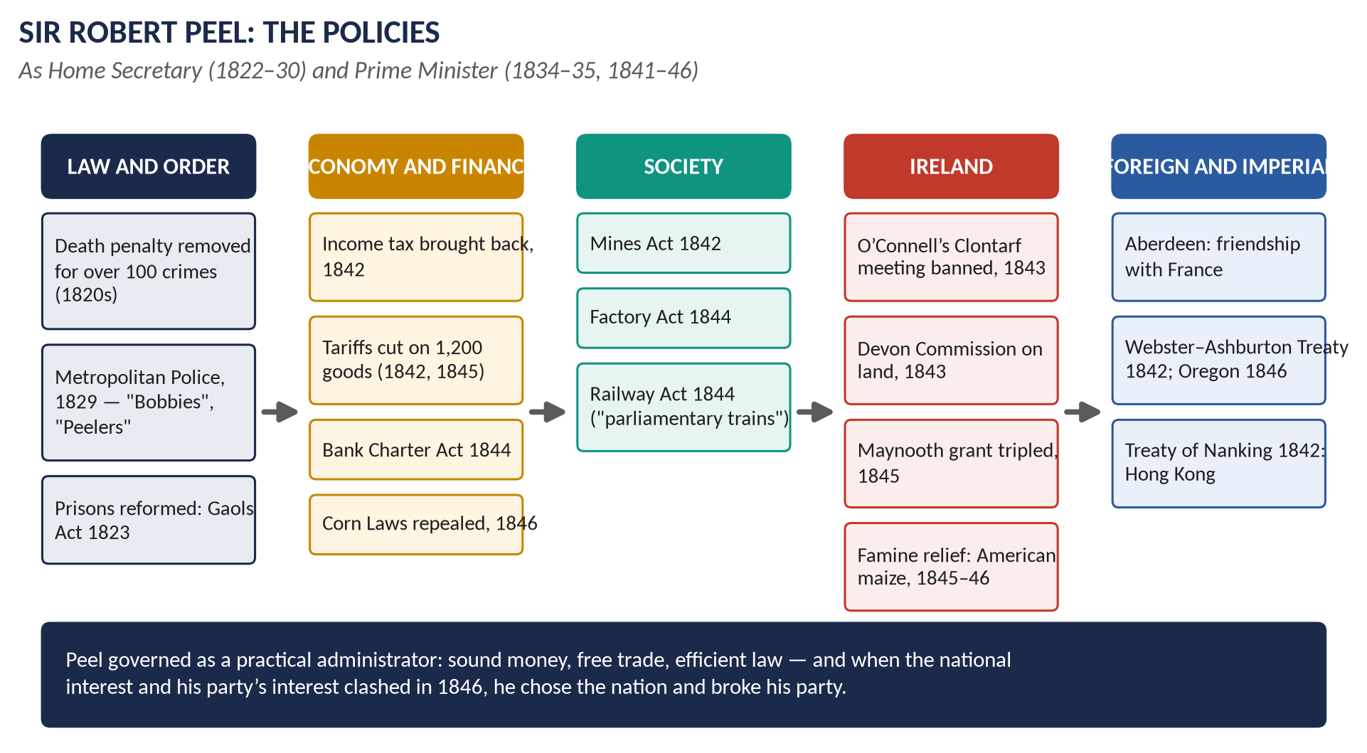
Figure 10 · Peel's policies at a glance.

Interior policy

(1) The first ministry and the Tamworth Manifesto (1834–35)
Appointed by William IV in December 1834, Peel issued the Tamworth Manifesto: he accepted the Reform Act as "a final and irrevocable settlement" and promised to correct proven abuses "in a friendly temper". He set up the Ecclesiastical Commission (1835) to reform the Church of England's finances. He lost the election and resigned in April 1835 — but the manifesto made the Tories the modern Conservative Party.

(2) Finance and the economy (1841–46)
- The problem in 1841: a deficit of about £7.5 million, depression, unemployment and Chartist unrest.
- The budget of 1842: income tax reintroduced in peacetime at 7d in the pound on incomes over £150 — so the poor did not pay; import duties cut on about 750 items; the Corn Law's sliding scale lowered.
- The budget of 1845: import duties abolished on about 450 items, including raw cotton; all export duties abolished.
- The Bank Charter Act (1844): only the Bank of England could issue new notes, and they had to be backed by gold — stable money and fewer bank failures.
- The Companies Act (1844) and the Railway Act (1844), with its cheap "parliamentary trains" at 1d a mile.
- Result: trade revived; by 1845 the budget was in surplus; the "hungry forties" eased.

(3) Social policy
- The Mines Act (1842): no women or girls, and no boys under 10, underground.
- The Factory Act (1844): women limited to 12 hours; children to 6½ hours; dangerous machinery to be fenced.
- Peel refused the Ten Hours Bill, fearing it would harm industry — showing the limits of his reforming.

(4) The repeal of the Corn Laws (1846)
- The Corn Laws protected British farmers by taxing imported grain — keeping bread dear.
- Pressure: the Anti-Corn Law League of Cobden and Bright.
- Peel's conversion: he came to believe that free trade meant cheap food, more trade and social peace.
- The trigger: the Irish famine (1845).
- Repeal passed in 1846 with Whig votes; two-thirds of Conservatives voted against. The Protectionists (Bentinck, Disraeli) then helped defeat Peel's Irish Coercion Bill, and he resigned (June 1846).

The Irish issue — particular emphasis
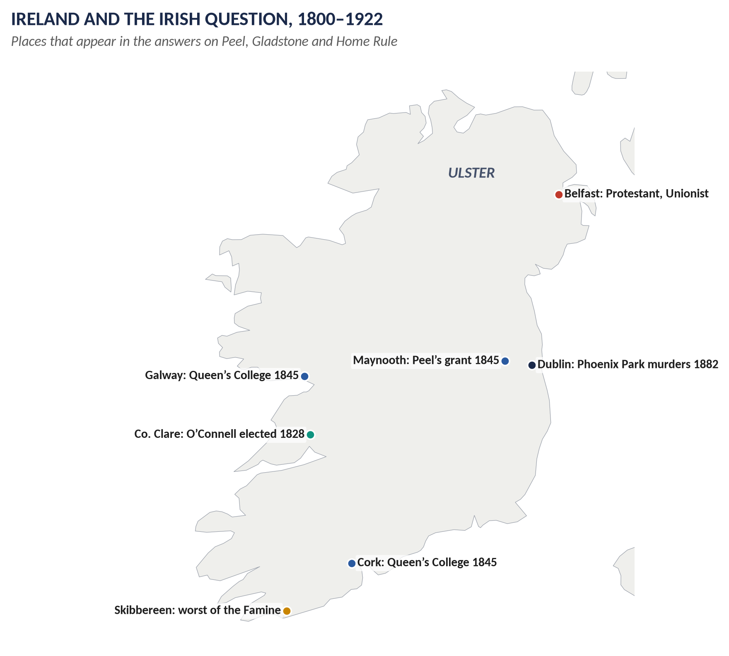
Figure 11 · Ireland in Peel's time.

(5) Peel and Ireland before 1841
- Chief Secretary for Ireland (1812–18): he set up the Peace Preservation Force (1814), the ancestor of the Irish police, and firmly opposed Catholic claims — the Irish called him "Orange Peel".
- Catholic Emancipation (1829): as leader of the Commons he carried the Catholic Relief Act after O'Connell's election in County Clare, to avoid civil war. It cost him his seat for Oxford University and the trust of the Ultras.

(6) The problem in 1841
Ireland had about 8 million people, most of them Catholic tenant farmers or labourers living on tiny plots and depending on the potato. Land belonged mostly to Protestant landlords. The Protestant Church of Ireland was the established church. And Daniel O'Connell had launched a mass campaign to repeal the Act of Union (1801) and restore an Irish parliament.

(7) Firmness: defeating Repeal
- 1843, "the Repeal Year": O'Connell held "monster meetings" of hundreds of thousands (Tara, August 1843).
- Peel sent troops and banned the final meeting at Clontarf (October 1843). O'Connell, a man of peace, obeyed; he was then arrested, tried and convicted of conspiracy (the House of Lords quashed the conviction in 1844).
- The Repeal movement lost its momentum; O'Connell's power declined.

(8) Conciliation: "killing Repeal by kindness"
Peel understood that force alone would not solve the Irish Question. He tried to win over the moderate Catholic middle class and the Catholic Church:
- The Devon Commission (1843–45) investigated the land system — landlord and tenant; its report recommended compensation for tenants' improvements (Peel's bill failed in the Lords).
- The Charitable Bequests Act (1844) made it easier to leave money to the Catholic Church.
- The Maynooth Grant (1845): the annual grant to the Catholic seminary at Maynooth, where priests were trained, was raised from about £9,000 to about £26,000 and made permanent. There was a storm of Protestant protest; Gladstone resigned from the cabinet; about half the Conservative MPs voted against.
- The Queen's Colleges (1845): new colleges at Belfast, Cork and Galway, open to all religions. Catholic bishops condemned them as "godless colleges".

(9) The Great Famine (1845–46)
- Autumn 1845: potato blight (a fungus) destroyed between a third and a half of the crop.
- Peel's response:
  - He secretly bought £100,000 of Indian corn (maize) from America, to be sold cheaply to keep food prices down.
  - He set up a Relief Commission and funded public works so people could earn money.
  - He decided the ports must be opened — and moved to repeal the Corn Laws.
- Assessment: Peel's relief in 1845–46 was prompt and, for the time, effective — few died in the first year. The great mortality came after his fall, under Russell's government (1846–49), when the blight returned and relief relied more on the market and the workhouse.

(10) Ireland and Peel's fall
The Irish Coercion Bill (to restore order in Ireland) became the occasion of Peel's defeat on 25 June 1846: Protectionist Conservatives, Whigs and Irish MPs voted together against it. Ireland thus destroyed his government.

Exterior policy

(11) Peace and conciliation under Aberdeen
- France: the first "entente cordiale" — Queen Victoria visited King Louis Philippe (1843); the Tahiti quarrel (the Pritchard affair, 1844) was settled peacefully.
- The United States: the Webster–Ashburton Treaty (1842) settled the Maine–New Brunswick border; the Oregon Treaty (1846) fixed the Canada–US boundary at the 49th parallel.

(12) Empire and Asia
- China: the First Opium War ended with the Treaty of Nanking (1842): Hong Kong ceded; five "treaty ports" opened.
- Afghanistan: withdrawal after the disaster of 1842 (Governor-General Ellenborough).
- India: conquest of Sind (1843, Sir Charles Napier); the First Anglo-Sikh War (1845–46).

Assessment
Area | Judgement
Interior | Outstanding: sound finance, free trade, social laws — the foundation of mid-Victorian prosperity
Exterior | Peaceful and sensible; good relations with France and the USA; empire expanded in Asia
Ireland | The most thoughtful policy of any Prime Minister before Gladstone: firmness against Repeal plus conciliation on land, religion and education; prompt famine relief. But it was too little, too late, it angered Protestants, and the Famine overwhelmed it

VERDICT · Conclusion
Peel was one of the ablest Prime Ministers of the nineteenth century. At home he restored the finances and set Britain on the road of free trade; abroad he kept the peace. In Ireland, with particular skill, he tried to combine the firm defence of the Union with real concessions to Catholic Ireland — but the Great Famine turned an Irish problem into a British crisis, led him to repeal the Corn Laws, and brought down his government and his party.

WHY THIS ANSWER SCORES · Why this answer scores
Three blocks exactly as the question asks — interior, Irish, exterior — with Ireland the largest, as "particular emphasis" demands · Irish policy is analysed as firmness plus conciliation plus famine relief · every point dated and quantified (7d, £150, £9,000 → £26,000, £100,000) · an assessment table and a clear verdict.

Answer 8 · Peel: The Most Liberal of Conservatives and the Most Conservative of Liberals
THE QUESTION · CSS 2020 · Q5 · Section A · 20 marks
'Peel was the most liberal of conservatives and the most conservative of liberals.' Examine the statement critically.

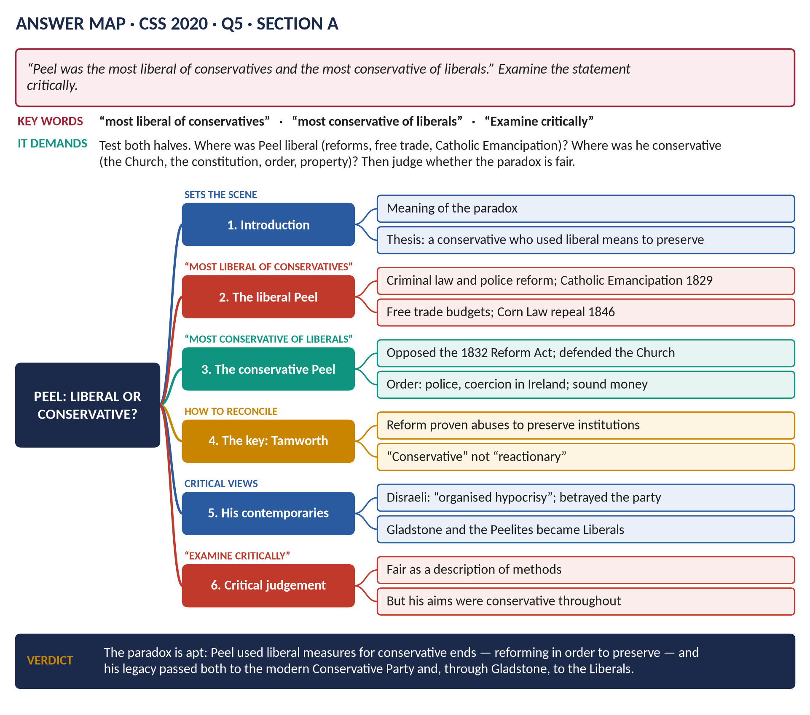
Figure 12 · The answer map for CSS 2020 · Q5 · Section A: every branch is one heading of the answer below.
DECODING THE QUESTION
A paradox (a statement that seems to contradict itself). "Examine the statement critically" = test both halves with evidence, then decide whether the description is fair. Half 1: in what ways was Peel liberal, though a Conservative? Half 2: in what ways was he conservative, even when doing liberal things? The key to a top answer is to reconcile the two — to explain how one man could be both.

The model answer

Introduction
Sir Robert Peel (1788–1850) founded the modern Conservative Party, yet his greatest acts — Catholic Emancipation (1829) and the repeal of the Corn Laws (1846) — were demanded by liberals and opposed by most Conservatives. His followers, the Peelites, including Gladstone, later helped form the Liberal Party. Hence the saying that he was "the most liberal of conservatives and the most conservative of liberals". This answer argues that the paradox is largely accurate: Peel used liberal means to achieve conservative ends — he reformed in order to preserve.

(1) Understanding the terms
- In the early nineteenth century a Conservative (Tory) defended the Crown, the Church of England, the Union with Ireland, the power of landowners and order.
- A Liberal (Whig or Radical) wanted reform of institutions, religious equality, free trade and wider political rights.

(2) The liberal Peel — "the most liberal of conservatives"
1. Criminal law reform (1820s): ended the death penalty for over 100 crimes; reformed prisons (Gaols Act 1823).
2. The Metropolitan Police (1829): order through a professional, civilian force rather than soldiers.
3. Catholic Emancipation (1829): he carried the bill he had opposed for twenty years — a victory for religious equality.
4. Acceptance of the Reform Act: the Tamworth Manifesto (1834) accepted 1832 as final and promised to reform abuses.
5. Free trade: the budgets of 1842 and 1845 swept away hundreds of tariffs; the income tax fell on the rich, not the poor.
6. The repeal of the Corn Laws (1846): the landowners' protection sacrificed for cheap food — the great liberal cause of the age.
7. Ireland: the Maynooth Grant (1845) and the non-denominational Queen's Colleges.
8. Social reform: the Mines Act (1842) and Factory Act (1844).

(3) The conservative Peel — "the most conservative of liberals"
1. He opposed the Reform Act of 1832 at every stage.
2. He defended the Church of England — the Ecclesiastical Commission (1835) was meant to strengthen it, not weaken it.
3. He defended the Union: he banned O'Connell's Clontarf meeting (1843) and used coercion in Ireland.
4. Order and property: the police, firm action against the Chartists, sound money (the gold standard 1819; the Bank Charter Act 1844).
5. Limits to reform: he rejected the Ten Hours Bill; he never supported further extension of the vote or the secret ballot.
6. Aristocratic government: he believed Britain should be governed by an educated, propertied elite.

(4) Reconciling the two — the Tamworth principle
The two lists are not contradictions. Peel's aims were always conservative: to preserve the Crown, the Church, the Union, property and aristocratic government. His methods were often liberal: he believed that institutions survive only if their proven abuses are removed, and that refusing all change leads to revolution. Tamworth said it clearly: review institutions "in a friendly temper", correcting abuses, to preserve them. So:
- Catholic Emancipation was granted to preserve the Union from civil war.
- Free trade and the income tax were meant to preserve social peace and the aristocratic state by removing the grievance of dear food.
- Corn Law repeal was meant to save the landed class from becoming the hated enemy of the people.
KEY IDEA · In one sentence
Peel was a conservative in ends and a liberal in means: he reformed in order to preserve.

(5) What contemporaries and historians said
- Disraeli attacked him as a traitor: he "caught the Whigs bathing and walked away with their clothes", and a Conservative government under him was "an organised hypocrisy" (1845).
- The Protectionists believed he had betrayed the landed interest that elected him.
- Gladstone regarded him as the greatest man he had known; the Peelites carried his ideas into the Liberal Party (1859).
- Norman Gash sees him as the founder of modern Conservatism — a party that accepts change to keep what matters.
- Boyd Hilton stresses his religious and moral economic ideas: free trade as a moral order.

(6) Critical judgement — is the statement fair?
- Fair, because his policies really did combine the two traditions, and his legacy passed to both parties — to Disraeli's reforming Conservatism and to Gladstone's Liberalism.
- But too neat, because Peel himself did not see a contradiction: he was a consistent conservative throughout, and his changes of mind came from evidence and circumstances, not from liberal principle. He never wanted democracy.
VERDICT · Conclusion
The description is broadly accurate. Peel carried out many of the greatest liberal measures of his age — Catholic Emancipation, free trade, the repeal of the Corn Laws — yet always for conservative purposes: to preserve the Crown, the Church, the Union and aristocratic government by removing the grievances that threatened them. He was, in truth, a conservative who reformed in order to preserve — and so both the Conservative and the Liberal parties could claim him.

WHY THIS ANSWER SCORES · Why this answer scores
It defines the two terms · it tests both halves with numbered evidence · it reconciles the paradox (ends v means, the Tamworth principle) — the step most candidates miss · it uses contemporaries (Disraeli, Gladstone) and historians (Gash, Hilton) · the judgement says both why the statement is fair and where it is too neat.

Answer 9 · Gladstone's Domestic Policy: The Climax of Liberalism
THE QUESTION · CSS 2017 · Q5 · Section A · 20 marks
'Gladstone's domestic policy was the climax of liberalism.' Discuss comprehensively.


Figure 13 · The answer map for CSS 2017 · Q5 · Section A: every branch is one heading of the answer below.
DECODING THE QUESTION
"Discuss comprehensively" = a full, wide-ranging answer covering all of his domestic policy, with a judgement. "Climax of liberalism" = the highest point of liberalism. So: (1) define nineteenth-century liberalism; (2) show how each area of Gladstone's domestic policy applied it; (3) test "climax" — was it the peak, and what were its limits? "Domestic" = at home, not foreign policy. The same question was set again in 2022 (Answer 10).

The model answer

Introduction
William Ewart Gladstone (1809–98) dominated British Liberalism for over thirty years. He was Chancellor of the Exchequer (1852–55, 1859–66) and Prime Minister four times (1868–74, 1880–85, 1886, 1892–94). His domestic policy — especially his first ministry, often called "the great ministry" — applied the principles of liberalism to almost every institution in Britain: the Church, the schools, the universities, the civil service, the army, the courts, elections and the national finances. This answer argues that his domestic policy was indeed the climax of classical, nineteenth-century liberalism — its fullest and most complete expression — although it had limits, and after him liberalism had to change.

(1) What was nineteenth-century liberalism?
1. Freedom of the individual: of religion, speech, trade and contract.
2. Merit, not privilege: jobs and positions to go to the ablest, not the best-connected or those who could pay.
3. Equality before the law: especially religious equality — no penalties for not belonging to the Church of England.
4. Free trade and laissez-faire: minimal government interference in the economy.
5. "Peace, Retrenchment and Reform": peace abroad; retrenchment — cutting government spending and taxes; reform of abuses.
6. Wider political rights: a wider, freer franchise for responsible citizens.
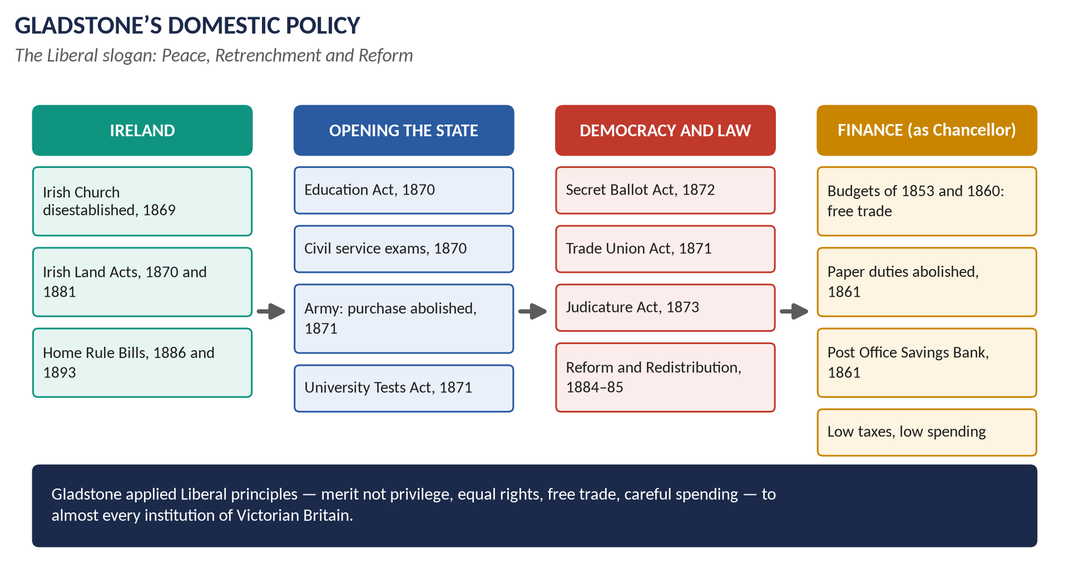
Figure 14 · Gladstone's domestic policy at a glance.

(2) Finance — the foundations (as Chancellor)
- The budget of 1853 cut duties on over 100 goods and planned the end of income tax.
- The budget of 1860, with the Cobden–Chevalier Treaty with France, removed duties on almost all imports: Britain became a free-trade country.
- Paper duties abolished (1861): when the Lords blocked it in 1860, Gladstone put all taxes into one Finance Bill that the Lords could not amend — a constitutional victory for the Commons.
- The Post Office Savings Bank (1861): safe saving for working people — self-help.
- Retrenchment: money should "fructify in the pockets of the people"; he scrutinised every shilling of spending.

(3) First ministry (1868–74): opening institutions to merit

(a) The civil service (1870)
Entry by open competitive examination, following the Northcote–Trevelyan Report (1854) — jobs by merit, not patronage.

(b) The army — Cardwell's reforms (1868–74)
- Purchase of commissions abolished (1871): officers had bought their ranks; now promotion was by merit. When the Lords blocked the bill, Gladstone used a royal warrant to end purchase.
- Short service (six years with the colours, six in reserve); flogging abolished in peacetime; regiments linked to counties; the War Office reorganised.

(c) The universities (1871)
The University Tests Act opened Oxford, Cambridge and Durham to non-Anglicans — Nonconformists, Catholics and Jews.

(4) First ministry: education, rights and law

(a) Forster's Education Act (1870)
Elected school boards were set up to build "board schools" wherever church schools were not enough. The Cowper-Temple clause kept denominational teaching out of board schools. Education for all became possible — "we must educate our masters".

(b) The Ballot Act (1872)
Secret voting freed voters from landlords and employers.

(c) Trade unions (1871)
The Trade Union Act gave unions legal status and protected their funds — but the Criminal Law Amendment Act made picketing illegal, angering workers.

(d) The Judicature Act (1873)
The old tangle of courts was merged into one Supreme Court of Judicature — the High Court and the Court of Appeal — cheaper, faster justice.

(e) The Licensing Act (1872)
Limited pub hours — a moral reform that angered brewers and drinkers.

(5) Ireland — "justice for Ireland"
- The Irish Church Act (1869): disestablished the Protestant Church of Ireland — religious equality.
- The Land Act (1870): compensation for evicted tenants and for improvements.
- The Land Act (1881): the "three Fs" — fair rent, fixity of tenure, free sale.
- Home Rule Bills (1886, 1893): self-government for Ireland (Answer 11).

(6) Second, third and fourth ministries: democracy and rights
- Married Women's Property Act (1882): married women could own property.
- Corrupt and Illegal Practices Act (1883): clean elections.
- Third Reform Act (1884) and Redistribution Act (1885): votes for rural workers; equal constituencies.
- Mundella's Education Act (1880): school compulsory for ages 5–10.
- Local Government Act (1894): elected parish and district councils.

(7) Why it can be called the "climax"
1. Completeness: no earlier government had applied liberal principles to so many institutions at once.
2. Merit: purchase, patronage and religious tests — the three great privileges of the old order — were swept away.
3. Equality: religious equality in Ireland and the universities; secret and wider voting.
4. Free trade and retrenchment reached their peak under his budgets.
5. Moral and popular force: through Midlothian (1879–80) Gladstone made liberalism a mass, moral crusade — "the People's William".

(8) The limits — and what came after
1. Little social reform: his laissez-faire beliefs meant little action on housing, health or poverty; Disraeli's government of 1874–80 did more.
2. He offended his own supporters: Nonconformists (the Education Act), workers (the Criminal Law Amendment Act), drinkers — hence defeat in 1874 in "a torrent of gin and beer".
3. Home Rule split the party (1886): the Whigs and Chamberlain's Radicals left; the Liberals were out of office for most of 1886–1905.
4. Liberalism changed: the New Liberalism of 1906–14 (old-age pensions, national insurance, the People's Budget) used the state to help the poor — which Gladstone distrusted. So his era was the peak of classical liberalism, after which it declined or transformed.
VERDICT · Conclusion
Gladstone's domestic policy was the climax of nineteenth-century liberalism. Through his budgets and his great first ministry he applied the principles of freedom, merit, equality and free trade to finance, the army, the civil service, the universities, the schools, the courts, elections and Ireland more completely than anyone before or after him. Its very completeness showed its limits: it did little for poverty, and after Gladstone liberalism had to become the New Liberalism of state welfare. His era was therefore both the summit of classical liberalism and the beginning of its end.

WHY THIS ANSWER SCORES · Why this answer scores
Defines liberalism first, then links each reform to a liberal principle · "comprehensively" is met: finance, all four ministries, Ireland · "climax" is tested with reasons for and limits, and with what came after · dates and names throughout · a clear, nuanced verdict.

Answer 10 · The Same Question, Set Again
THE QUESTION · CSS 2022 · Q2 · Section A · 20 marks
The domestic policy of Gladstone was the climax of liberalism during the 19th century. Discuss and analyze.

DECODING THE QUESTION
The full question: "The domestic policy of Gladstone was the climax of liberalism during the 19th century. Discuss and analyze." This is almost word for word 2017 Q5 (Answer 9). The added words "during the 19th century" and "analyze" invite you to compare Gladstone with other nineteenth-century liberals.

How to reuse Answer 9
1. Write Answer 9 in full, with its figure and headings.
2. Add one section before "The limits": "Gladstone compared with other nineteenth-century liberals" —
  - The Whigs of 1830–41 (Grey, Melbourne): the Reform Act and the Acts of the 1830s — important, but limited and aristocratic.
  - Peel (a Conservative who carried out liberal economics).
  - Palmerston (Liberal PM 1859–65): liberal abroad, but at home opposed further reform.
  - Gladstone: the most complete and consistent application of liberal principles at home — hence the climax.
3. "Analyze": in section (7), rank the reforms — the civil service exams and the end of army purchase (merit) and the ballot (freedom) as the purest expressions of liberalism.
4. Conclusion: as Answer 9, adding that no nineteenth-century government matched the first ministry.
WHY THIS ANSWER SCORES · Why this works
The examiner who repeats a question is testing whether candidates have a prepared answer and can adjust it to small changes of wording. Adding the comparison meets "during the 19th century" and "analyze".

Answer 11 · The Irish Question and Liberal Policy, 1886–1894
THE QUESTION · CSS 2024 · Q2 · Section A · 20 marks
Define the 'Irish Question'. Also discuss the policy of the Liberal Party on the said issue from 1886 to 1894.

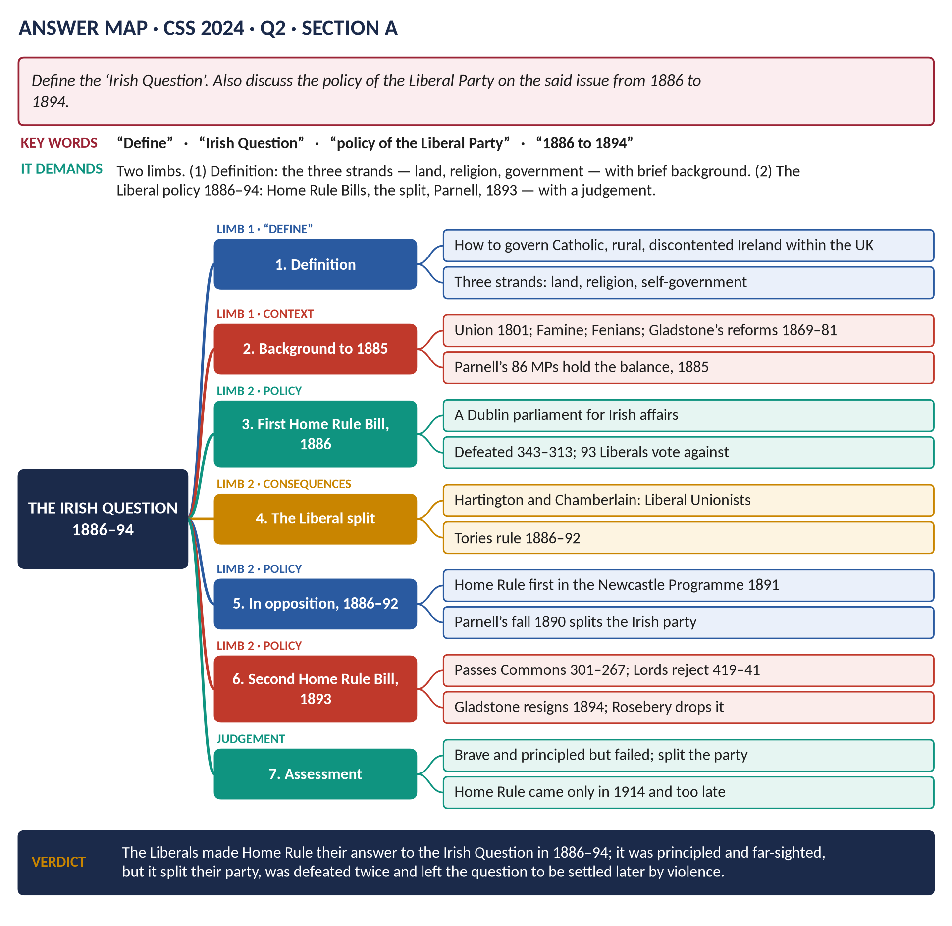
Figure 15 · The answer map for CSS 2024 · Q2 · Section A: every branch is one heading of the answer below.
DECODING THE QUESTION
Two limbs. (1) "Define the 'Irish Question'" — say clearly what it was (its three strands) with a little background; a definition in one or two sentences, then explanation. (2) "Discuss the policy of the Liberal Party on the said issue from 1886 to 1894" — the two Home Rule Bills, the split, the years in opposition, and judge the policy. Stay within 1886–94 for the second limb; earlier events are background only.

The model answer

Introduction
The Irish Question was the long-running problem of how Ireland should be governed, and how the grievances of its mainly Catholic, mainly rural people over land, religion and self-government could be met within the United Kingdom. From 1886 to 1894 the Liberal Party under Gladstone answered it with a bold policy: Home Rule — a parliament in Dublin for Irish affairs. The policy was principled and far-sighted, but it split the Liberal Party, was defeated twice, and left the Irish Question to be settled later, and more violently.

Limb 1 · Defining the Irish Question

(1) The definition
The Irish Question was the problem of governing Ireland within the United Kingdom after the Act of Union (1801) — a problem made up of the Irish land system, the position of the Catholic majority and the Protestant established Church, and the growing Irish demand for self-government.

(2) The three strands

(a) Land
Most land was owned by Protestant landlords, many of them absentees living in England. Most Irish people were Catholic tenant farmers or labourers with no security: they could be evicted at the landlord's will, and if they improved their land, the landlord could raise their rent. Rural poverty was extreme; the Great Famine (1845–49) killed about one million and drove another million to emigrate.

(b) Religion
About four-fifths of the Irish were Catholic, yet until 1869 the official, state-supported church was the Protestant Church of Ireland, to which Catholics paid tithes. Catholics could not sit in Parliament until 1829.

(c) Self-government
Ireland lost its own parliament in 1801 and was governed from London. Irish nationalists demanded first Repeal of the Union (O'Connell, 1840s), then Home Rule (Isaac Butt, 1870s; Charles Stewart Parnell, 1880s), and some — the Fenians — full independence by force.

(d) Ulster
In the north-east, Ulster, a Protestant majority, loyal to Britain and more industrial, wanted to keep the Union — a complication that grew more serious over time.
Figure 16 · Ireland and the Irish Question.

(3) The background to 1886
- 1868: Gladstone: "My mission is to pacify Ireland."
- 1869: the Irish Church disestablished. 1870: the first Land Act.
- 1879–82: the Land League (Michael Davitt) and the "Land War"; the Land Act of 1881 (the "three Fs": fair rent, fixity of tenure, free sale); the Kilmainham Treaty with Parnell (1882); the Phoenix Park murders (1882).
- 1885: after the Third Reform Act, Parnell's Irish Party won 86 seats — exactly the number that held the balance between the Liberals (335) and the Conservatives (249). In December the "Hawarden Kite" (a press leak by Gladstone's son) revealed that Gladstone had become a Home Ruler.

Limb 2 · The Liberal policy, 1886–1894

(4) Why Gladstone adopted Home Rule
1. Democracy: Ireland had voted overwhelmingly for Home Rule in 1885 — 86 of 103 seats.
2. Justice: Gladstone believed Ireland had been misgoverned and deserved to manage its own affairs.
3. Coercion had failed: repeated special laws had not brought peace.
4. Saving the Union and the empire: Home Rule would remove Irish grievance and so strengthen the link with Britain — as self-government had in Canada.
5. Politics: he needed Parnell's votes to govern.

(5) The First Home Rule Bill (April 1886)
- Terms: an Irish parliament and executive in Dublin to manage Ireland's domestic affairs; Westminster kept the Crown, defence, foreign policy, trade and customs; Irish MPs would no longer sit at Westminster. A companion Land Purchase Bill would help tenants buy out landlords.
- Opposition:
  - The Conservatives (Lord Salisbury) — defence of the Union and the empire.
  - The Whig Liberals under Lord Hartington — fear for property and the Union.
  - The Radical Joseph Chamberlain — who wanted local councils, not a separate parliament, and objected to removing Irish MPs from Westminster.
  - Ulster Protestants — "Home Rule is Rome Rule"; Lord Randolph Churchill: "Ulster will fight, and Ulster will be right".
- The vote: defeated on 8 June 1886 by 343 to 313; 93 Liberals voted against it.

(6) The split and the Unionist years (1886–92)
- The rebels formed the Liberal Unionists and allied with the Conservatives. At the election of July 1886 the Unionists won decisively; Salisbury governed until 1892.
- The Liberal Party lost most of its Whig aristocrats, much of its wealth, and Chamberlain's Radical following in Birmingham.
- Unionist policy was coercion (Balfour's Crimes Act, 1887) with land purchase — "killing Home Rule with kindness".
- 1887–89: The Times published letters linking Parnell to the Phoenix Park murders; they were exposed as forgeries by Richard Pigott (1889). Sympathy for Parnell and the Liberals grew.
- 1890: Parnell was named in the O'Shea divorce case. Nonconformist Liberals refused to work with him; Gladstone said Home Rule depended on Parnell's retirement; the Irish Party split (Parnell died in 1891).
- 1891: the Newcastle Programme made Home Rule the Liberals' first promise.

(7) The Second Home Rule Bill (1893)
- The 1892 election gave the Liberals and Irish Nationalists a majority of about 40; Gladstone, aged 82, became Prime Minister for the fourth time.
- The bill (February 1893): similar to 1886, but 80 Irish MPs would stay at Westminster.
- It passed the Commons after 82 days of debate — 301 to 267 on third reading (1 September 1893).
- The House of Lords rejected it by 419 to 41 (8 September 1893) — one of the largest majorities in its history.
- Gladstone wanted to fight an election against the Lords; his cabinet refused. He resigned in March 1894.
- His successor, Lord Rosebery, said Home Rule must wait until England, "the predominant partner", was convinced — effectively dropping it.

(8) Assessment of the Liberal policy
Strengths | Weaknesses
Principled: it respected the democratic wish of the Irish people | Split the Liberal Party and kept it out of power for most of 1886–1905
Far-sighted: a peaceful solution that might have prevented later violence | Ignored Ulster: no separate provision for the Protestant north
Made Home Rule the policy of a great party, keeping Irish nationalism constitutional for a generation | Failed twice; could never overcome the House of Lords before 1911
Gladstone's courage and moral leadership | Made the Liberals dependent on Irish votes; alienated English voters

(9) The epilogue
Home Rule finally passed in 1914 (under the Parliament Act) but was suspended for the war; the Easter Rising (1916), the War of Independence and the Anglo-Irish Treaty led to the Irish Free State (1922) and a separate Northern Ireland. Many historians think that if Home Rule had passed in 1886 or 1893, Ireland might have stayed peacefully within the United Kingdom.
VERDICT · Conclusion
The Irish Question was the problem of governing a Catholic, rural and discontented Ireland — divided over land, religion and self-government — within the United Kingdom. From 1886 to 1894 the Liberal Party, led by Gladstone, answered it with Home Rule. The policy was principled and perhaps the best chance of a peaceful settlement, but it split the party, was defeated in the Commons in 1886 and by the Lords in 1893, and left the question to be decided a generation later by rebellion and partition.

WHY THIS ANSWER SCORES · Why this answer scores
A clear definition in a box, then its three strands plus Ulster · limb 2 stays within 1886–94 and covers both bills, the split, the opposition years and Rosebery · vote figures (343–313, 301–267, 419–41) · the why of Gladstone's policy · an assessment table and an epilogue that shows the long-term view.

Answer 12 · The Evolution of Party Politics in Nineteenth-Century Britain
THE QUESTION · CSS 2025 · Q4 · Section A · 20 marks
Examine the evolution of party politics in Britain during the 19th century, focusing on the rise of the Conservative and Liberal parties, and the changing relationship between government, parliament and the electorate.

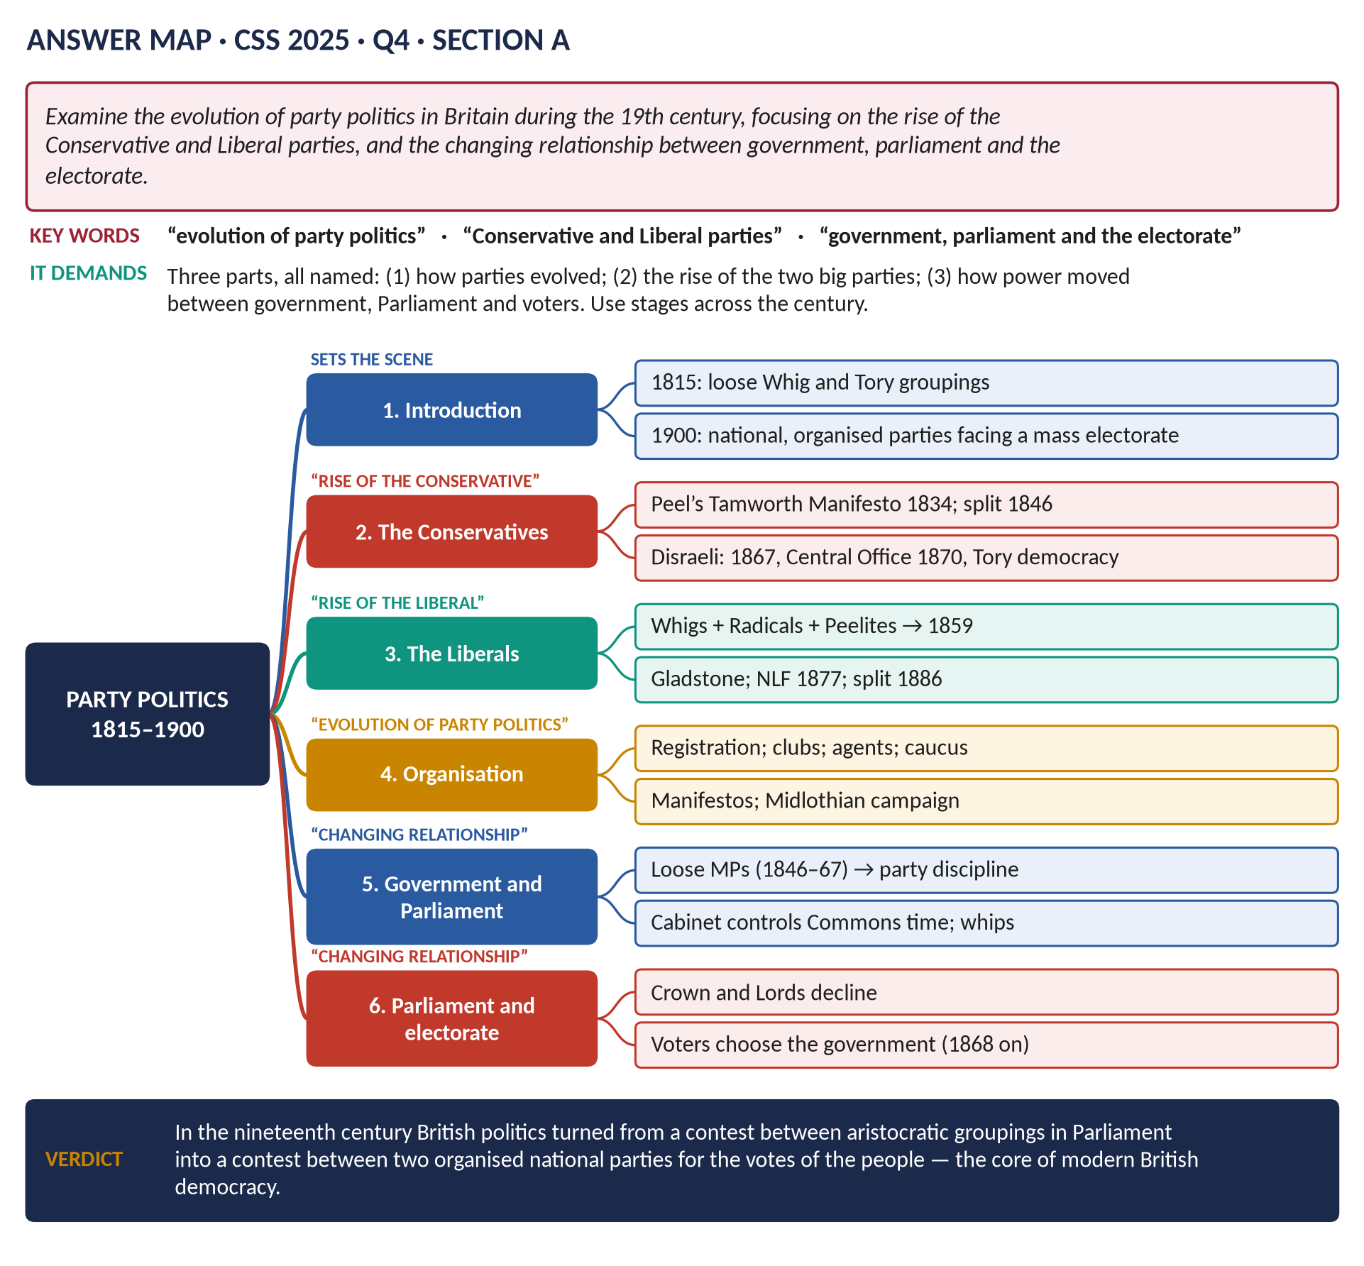
Figure 17 · The answer map for CSS 2025 · Q4 · Section A: every branch is one heading of the answer below.
DECODING THE QUESTION
Three parts, all named: (1) "the evolution of party politics" — how parties changed from loose groups to organised national parties; (2) "the rise of the Conservative and Liberal parties" — the story of each; (3) "the changing relationship between government, parliament and the electorate" — how power moved between the Crown and ministers, the Commons and the Lords, and the voters. "Examine" = explain with evidence and judge. Organise by stages of the century.

The model answer

Introduction
In 1815 British politics was a contest between loose groupings of aristocrats and gentlemen in Parliament — "Whigs" and "Tories" — with no national organisation, no membership and no programmes; the Crown still chose the ministers, and a small electorate rarely decided who governed. By 1900 two organised national parties — the Conservatives and the Liberals — competed for the votes of about six million men, with central offices, local associations, leaders who campaigned across the country and programmes of promises; and the voters, through general elections, chose the government. This answer examines that evolution in four stages.
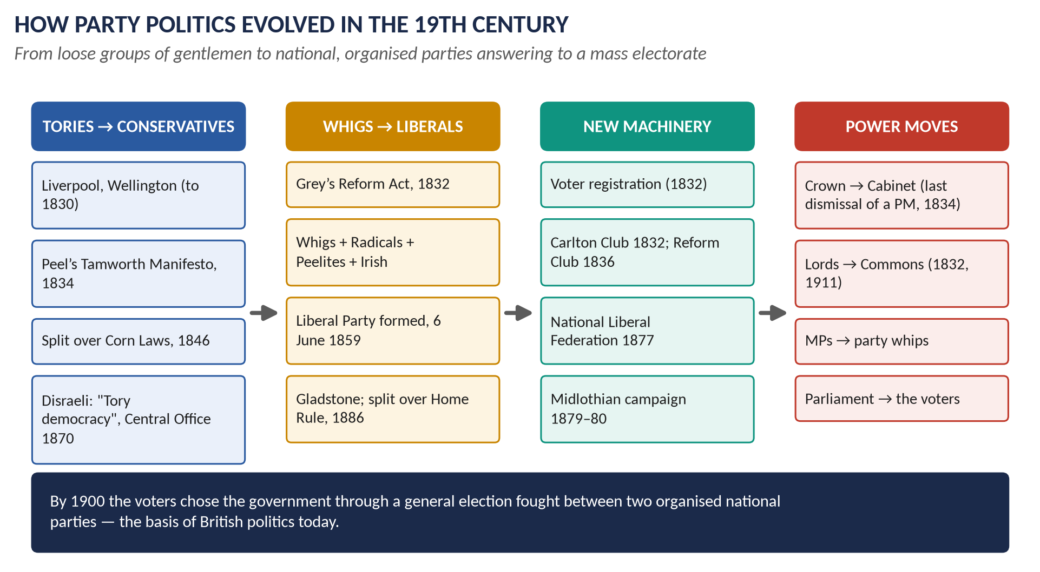
Figure 18 · How party politics evolved.

(1) The starting point: politics in 1815
- Whig and Tory were names from the 1680s (Topic 1). They meant attitudes and family connections, not organised parties.
- Many MPs were independent country gentlemen; others were attached to a great patron.
- The Crown chose the Prime Minister; governments used royal patronage (jobs, honours) to keep majorities, and usually won elections.
- The electorate was tiny (about 500,000), and many seats were uncontested or controlled by patrons.

(2) Stage 1 · 1832–1846: the birth of modern parties
- The Reform Act (1832) created registration: voters had to be on a register, and each side needed local agents and registration societies to put its supporters on it and challenge its opponents' — the beginning of local party organisation.
- Clubs acted as national headquarters: the Carlton Club (1832) for the Tories, the Reform Club (1836) for the Whigs and Liberals.

(a) The rise of the Conservatives
- The name "Conservative" came into use around 1830 and was fixed by Peel's Tamworth Manifesto (1834) — the first party programme addressed to the whole electorate.
- Peel accepted the Reform Act and promised careful reform, attracting middle-class voters. With the party agent F. R. Bonham, he built an organisation that won a majority of about 80 in 1841 — the first time a party had won power from opposition at a general election.

(b) The Whig-Liberal alliance
- The Lichfield House Compact (1835) joined Whigs, Radicals and O'Connell's Irish MPs — the coalition that became Liberalism.
- Melbourne's Whig governments (1835–41).

(c) Government, Crown and electorate
- 1834: William IV dismissed Melbourne and appointed Peel, but the voters did not give Peel a majority and he resigned in 1835 — the last royal dismissal of a Prime Minister.
- 1839: the Bedchamber Crisis — the last time a monarch's personal preference decisively shaped a government.
- So the power to make governments began to pass from the Crown to the Commons and the voters.

(3) Stage 2 · 1846–1867: fluid parties and a powerful Commons
- The Corn Law split (1846) broke the Conservatives into Protectionists (led by Lord Derby and Disraeli) and Peelites (Gladstone, Aberdeen, Graham).
- For twenty years governments were coalitions that rose and fell in the Commons (1846, 1852, 1855, 1858, 1859); MPs voted freely. Historians call it the "golden age of the private member" — the high point of the power of Parliament over government.
- The rise of the Liberals: on 6 June 1859, at Willis's Rooms in London, Whigs, Radicals, Peelites and Irish members agreed to combine to defeat Derby. The Liberal Party was born, led by Palmerston (PM 1859–65), with Gladstone as Chancellor.

(4) Stage 3 · 1867–1886: mass parties and party government
After the Second Reform Act (1867) — which roughly doubled the electorate to about 2.5 million and added working men — and the secret ballot (1872), voters could no longer be bribed or managed personally. Parties had to organise and persuade.

(a) The Conservatives under Disraeli
- The National Union of Conservative and Constitutional Associations (1867), including working-men's clubs.
- Conservative Central Office (1870), run by John Gorst — the first professional national party office.
- Disraeli's speeches at Manchester and the Crystal Palace (1872) gave the party a programme: the constitution, the empire and the condition of the people — "Tory democracy". It won the 1874 election — its first majority since 1841.
- The Primrose League (1883), with over a million members by 1891, brought women and working people into Conservative activity.

(b) The Liberals under Gladstone
- Joseph Chamberlain's Birmingham "caucus" — an elected, ward-by-ward organisation.
- The National Liberal Federation (1877).
- Gladstone's Midlothian campaign (1879–80): the first modern national campaign — a party leader speaking to vast crowds, his speeches reported in full by the press. It won the 1880 election.

(c) The electorate decides
In 1868 Disraeli, defeated at the election, resigned at once instead of waiting to be defeated in Parliament — the first Prime Minister to do so. Gladstone did the same in 1874. From now on, general elections, not parliamentary votes, made and unmade governments.

(5) Stage 4 · 1886–1900: realignment
- The Home Rule split (1886): the Liberal Unionists (Hartington, Chamberlain) joined the Conservatives; the combined Unionists ruled for most of 1886–1905.
- The Newcastle Programme (1891): a detailed list of Liberal promises — the ancestor of the modern manifesto.
- New parties: the Independent Labour Party (1893) and the Labour Representation Committee (1900).

(6) The changing relationship between government, Parliament and electorate — summarised
Relationship | Around 1815–30 | Around 1880–1900
Crown ↔ government | The monarch chooses and can dismiss ministers | The monarch appoints the leader of the winning party; Bagehot (1867): the Crown "dignified", the Cabinet "efficient"
Lords ↔ Commons | The Lords powerful; patrons nominate MPs | The Commons dominant (1832, 1861 Finance Bill, 1911)
Government ↔ Commons | Loose loyalties; governments often defeated | Party whips and discipline; government controls Commons time; the closure (1882)
Parliament ↔ electorate | Small electorate; elections rarely change governments | Mass electorate; national campaigns; the voters choose the government (from 1868)

(7) Examination — why did party politics evolve this way?
1. Reform Acts: each wider franchise forced parties to organise and appeal to the people.
2. The secret ballot and the Corrupt Practices Act ended bribery and influence, so persuasion replaced management.
3. Great issues — Reform, the Corn Laws, Ireland — divided politicians along clear lines.
4. Great leaders — Peel, Disraeli, Gladstone — gave each party an identity.
5. Railways, the telegraph and a cheap press made national campaigns possible.
VERDICT · Conclusion
During the nineteenth century British party politics evolved from a contest between aristocratic groupings inside Parliament into a contest between two organised national parties for the votes of the people. The Conservative Party rose from Peel's Tamworth Manifesto to Disraeli's Tory democracy; the Liberal Party from the Whig–Radical alliance to Gladstone's mass movement. Power moved from the Crown to the Cabinet, from the Lords to the Commons, and above all from Parliament to the electorate — the essential features of British democracy today.

WHY THIS ANSWER SCORES · Why this answer scores
All three named parts have their own sections — evolution, the two parties, the changing relationships · stages give clear structure · each party's organisations and dates (1832, 1834, 1859, 1867, 1870, 1877, 1883) · the relationships are summarised in a before-and-after table · an examination of the causes turns narrative into analysis.

Part Two — The Past MCQs, Solved

CSS 2024 · MCQ 19
Who was the longest-reigning Hanoverian monarch?
(A) Edward I | (B) Edward III | (C) Edward II | (D) None of these

REMEMBER · Answer: D. None of these — Queen Victoria
The House of Hanover reigned from 1714 to 1901. Its longest-reigning monarch was Queen Victoria (1837–1901, over 63 years). The options (Edward I, II, III) were medieval kings, not Hanoverians — so the key is "None of these".

CSS 2025 · MCQ 8
Which Prime Minister repealed the Corn Laws?
(A) William Gladstone | (B) Benjamin Disraeli | (C) Robert Peel | (D) None of these

REMEMBER · Answer: C. Robert Peel
Sir Robert Peel repealed the Corn Laws in 1846, after the Irish potato famine, splitting his Conservative Party.

CSS 2025 · MCQ 10
Which economic policy dominated Victorian Britain?
(A) Protectionism | (B) Free trade | (C) Socialism | (D) None of these

REMEMBER · Answer: B. Free trade
After Peel's budgets and the repeal of the Corn Laws (1846), and Gladstone's budget of 1860, free trade dominated Victorian economic policy until the First World War.

CSS 2026 · MCQ 6
The Peterloo Massacre occurred in which city?
(A) Birmingham | (B) Liverpool | (C) London | (D) None of these

REMEMBER · Answer: D. None of these — Manchester
Peterloo (16 August 1819) took place at St Peter's Fields, Manchester — not in any of the cities listed, so the key is "None of these".

CSS 2026 · MCQ 7
The Irish Famine was chiefly caused by the failure of which crop?
(A) Wheat | (B) Barley | (C) Potato | (D) None of these

REMEMBER · Answer: C. Potato
The Great Famine (1845–49) was caused by potato blight, a fungus that destroyed the potato — the main food of about 3 million Irish people.

CSS 2026 · MCQ 8
Women over the age of 30 first gained the parliamentary vote in:
(A) 1900 | (B) 1907 | (C) 1910 | (D) None of these

REMEMBER · Answer: D. None of these — 1918
Women over 30 first got the parliamentary vote under the Representation of the People Act 1918 — none of the listed years.

CSS 2026 · MCQ 16
The Reform Act 1832 extended political representation mainly to:
(A) All men | (B) Women | (C) Middle-class men | (D) None of these

REMEMBER · Answer: C. Middle-class men
The Reform Act 1832 gave the vote in the towns to £10 householders — mainly middle-class men.

Part Three — Five Predicted Questions, with Outlines
WHAT THE EXAMINER HAS ASKED · Why these five
They cover parts of syllabus Heads VIII–IX that have not yet been set as full questions, or natural next angles on the favourite themes.

Predicted 1 · "Lord Liverpool's government moved from repression to reform. Discuss."
- Introduction: Liverpool PM 1812–27; thesis: a real change in 1822, but continuity of aims (order and stability).
- Repression 1815–20: Corn Law, income tax abolished, Habeas Corpus suspended (1817), Peterloo and the Six Acts (1819).
- Why the change: return of prosperity; new ministers (Peel, Huskisson, Canning, Robinson) after 1822; fear of revolution receding.
- Reform 1822–27: criminal law and prisons; tariff cuts and reciprocity; Combination Acts repealed (1824); a liberal foreign policy.
- Verdict: a shift in methods, not in purpose — pragmatic conservatism.

Predicted 2 · "Why were the Corn Laws repealed in 1846, and what were the consequences?"
- Causes: the Anti-Corn Law League (Cobden, Bright; propaganda, penny post, registration); Peel's free-trade conversion; the Irish potato blight; economic arguments (cheap food, exports).
- The passage: Whig votes; 231 Conservatives against.
- Consequences: the Conservative split (Peelites v Protectionists), no Conservative majority until 1874; the Peelites join the Liberals (1859); free trade as national policy; "golden age" of farming (1850–73) then agricultural depression; cheaper food.
- Verdict: a victory of the industrial middle class and of Peel's idea of the national interest.

Predicted 3 · "Assess Disraeli's contribution to the Conservative Party and to social reform."
- Rise: attacked Peel (1845–46); led the Protectionists in the Commons.
- The party: Second Reform Act 1867; Central Office 1870; Crystal Palace and Manchester speeches 1872 — empire, constitution, the condition of the people; "One Nation", "Tory democracy".
- Social reform 1874–80 (Cross): Artisans' Dwellings, Public Health, Sale of Food and Drugs, Conspiracy and Protection of Property (1875); Merchant Shipping (1876); Factory Act (1878).
- Limits: permissive laws; the reforms were drafted by Cross; the party of land and Church remained.
- Verdict: he gave Conservatism a popular, national and imperial identity that lasted.

Predicted 4 · "Discuss the causes and consequences of the Great Irish Famine (1845–49)."
- Causes: dependence on the potato; tiny holdings; population growth; the blight (1845–48); the land system; the government's reliance on the free market after 1846.
- Response: Peel's maize and relief; Russell's public works, soup kitchens (1847), the Poor Law; exports of food continued.
- Consequences: about 1 million dead, 1 million emigrants; population fell from about 8.2 to 6.5 million; lasting hatred of British rule; Irish America; Fenianism; the land question and Home Rule.
- Verdict: a natural disaster turned into a political catastrophe by poverty and policy.

Predicted 5 · "Examine the causes and significance of the Parliament Act of 1911."
- Causes: the Lords' Conservative majority blocking Liberal bills; the rejection of the People's Budget (1909); two elections in 1910; the King's promise to create peers.
- Terms: no Lords' veto — only a two-year delay; money bills not delayed; five-year parliaments.
- Significance: supremacy of the Commons; Home Rule (1914) possible; Welsh Church disestablishment; the Lords weakened again in 1949 and reformed in 1958 and 1999.
- Verdict: completed the constitutional side of democracy begun in 1832.

